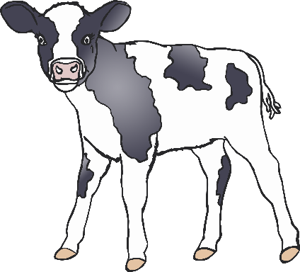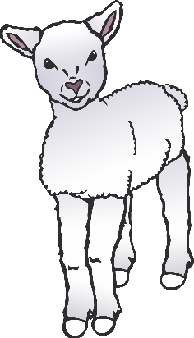

How many……?

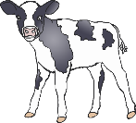

Calves

Lambs

Chicks

Puppies

Piglets

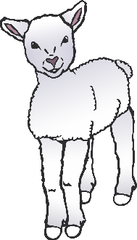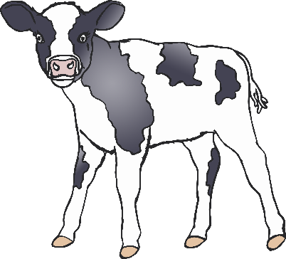

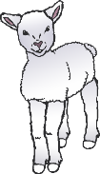

© 2021 Little Owls Resources

How many……?

Ducks

Geese

Horses

Chickens

© 2021 Little Owls Resources