© 2022 Little Owls Resources

How many **suns** are there?

3

6

7

© 2022 Little Owls Resources

How many **buckets** are there?

8

6

4

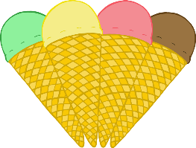

© 2022 Little Owls Resources

How many **sunglasses** are there?

5

9

3

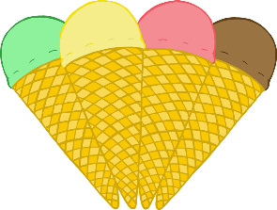

© 2022 Little Owls Resources

How many **ice-creams** are there?

3

5

96

© 2022 Little Owls Resources

How many **sandcastles** are there?

7

2

6

© 2022 Little Owls Resources

How many **watermelons** are there?

8

4

7

