I Spy – Count and Choose

Space

These sheets are intended to be laminated and then used with clothes pegs.

Children to independently count the requested item (top right of sheet) and then clip a clothes peg on the bottom of the sheet over the correct number.

© 2021 Little Owls Resources

**How many meteors are there?**

3

7

6

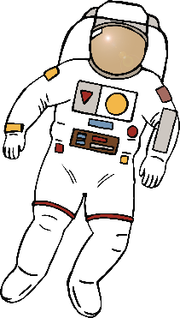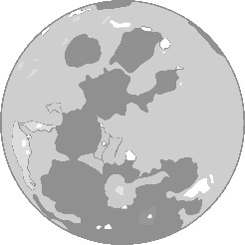

© 2021 Little Owls Resources

**How many suns are there?**

4

6

8

© 2021 Little Owls Resources

**How many Earths are there?**

5

9

3

© 2021 Little Owls Resources

**How many moons are there?**

3

5

96

© 2021 Little Owls Resources

**How many asteroids are there?**

7

2

6

© 2021 Little Owls Resources

**How many astronauts are there?**

8

4

7