© 2021 Little Owls Resources

**How many piglets are there?**

3

7

6

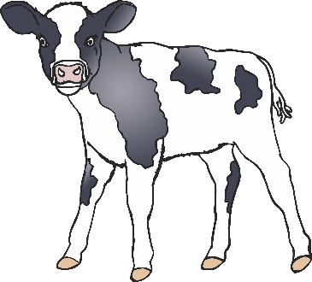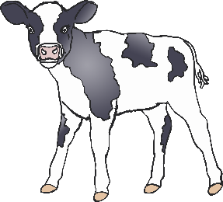

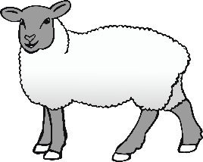

© 2021 Little Owls Resources

**How many horses are there?**

4

6

8

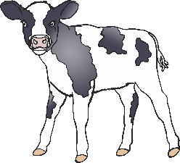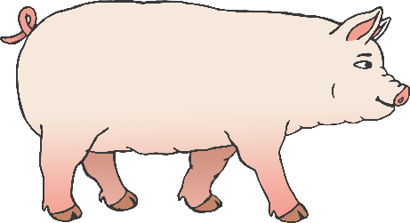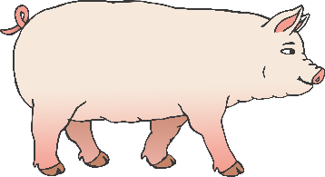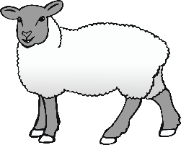

© 2021 Little Owls Resources

**How many chicks are there?**

5

9

3

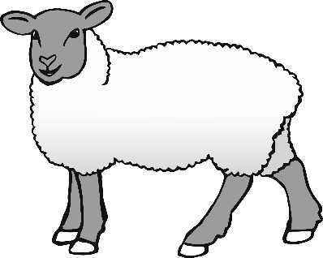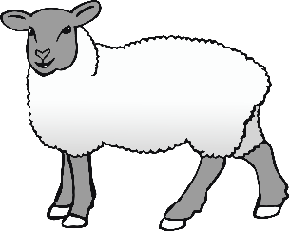

© 2021 Little Owls Resources

**How many sheep are there?**

3

5

96

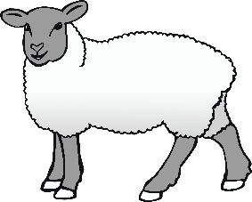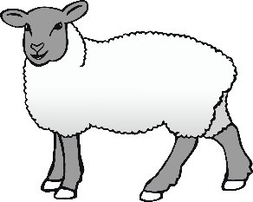

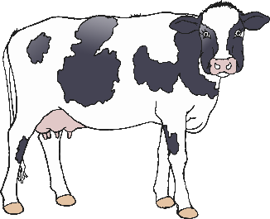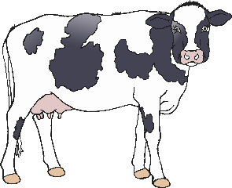

© 2021 Little Owls Resources

**How many cows are there?**

7

2

6

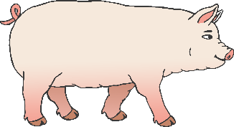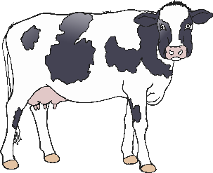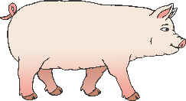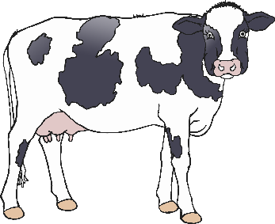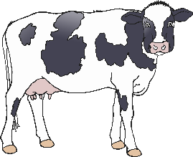

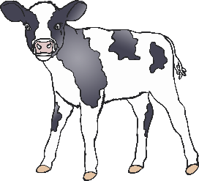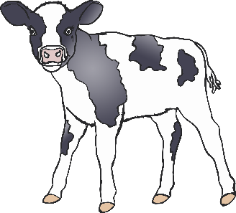

© 2021 Little Owls Resources

**How many ducks are there?**

8

4

7