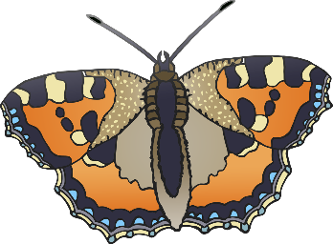

© 2021 Little Owls Resources

**How many are there?**

3

7

4

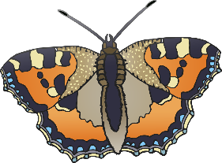

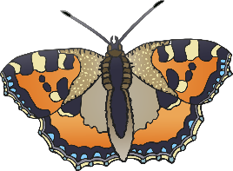

© 2021 Little Owls Resources

**How many are there?**

4

6

8

© 2021 Little Owls Resources

**How many are there?**

5

9

3

© 2021 Little Owls Resources

**How many are there?**

3

5

96

© 2021 Little Owls Resources

**How many are there?**

7

2

6

© 2021 Little Owls Resources

**How many are there?**

8

4

7