How are you feeling today?

© 2020 Little Owls Resources

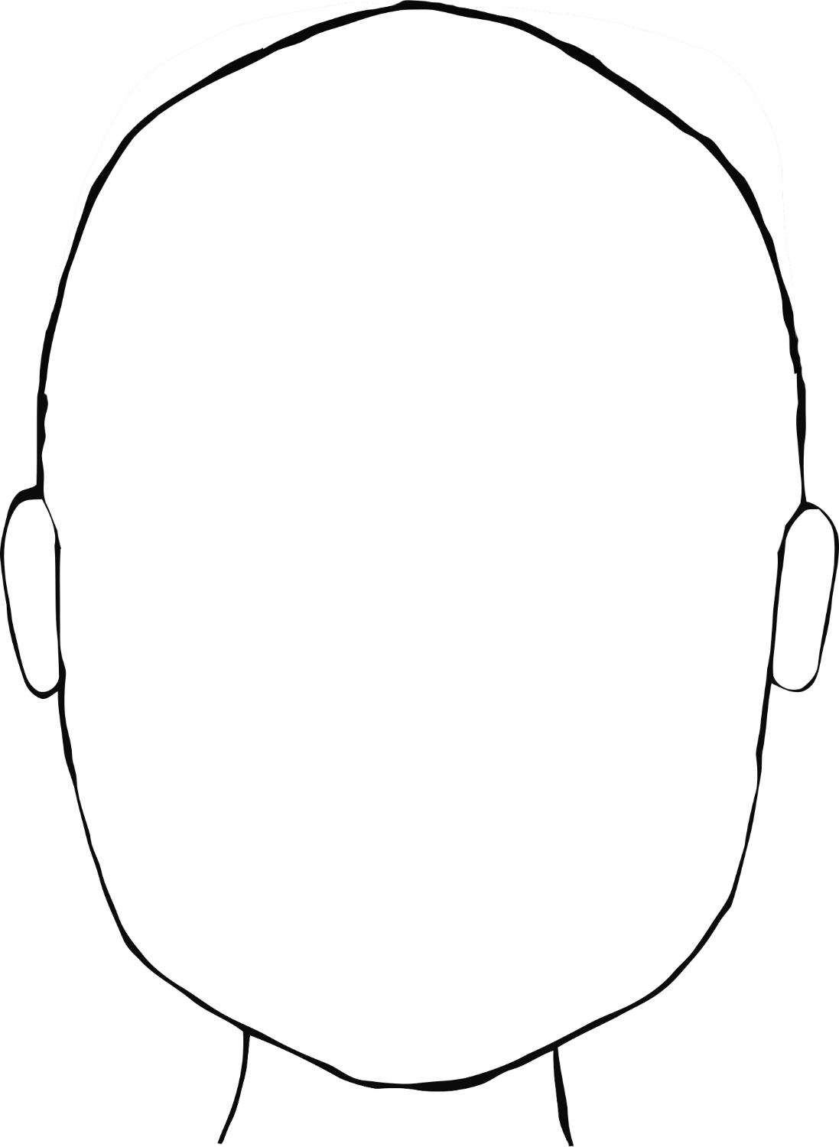

© 2020 Little Owls Resources

How are you feeling today?