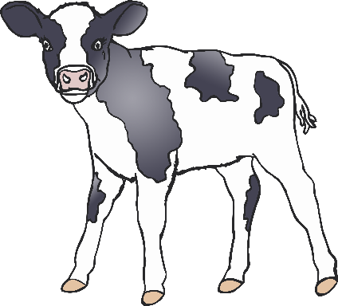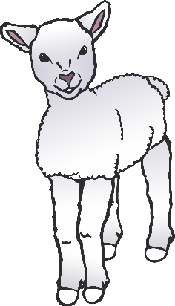

How many lambs are there?

How many calves are there?

How many piglets are there?

How many puppies are there?

How many chicks are there?

© 2021 Little Owls Resources

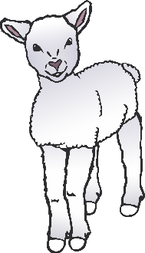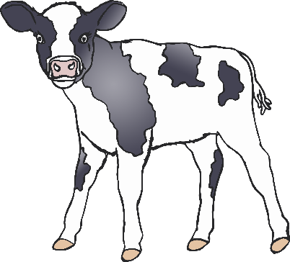

How many horses are there?

How many geese are there?

How many ducks are there?

How many chickens are there?

© 2021 Little Owls Resources