**Horse body parts**

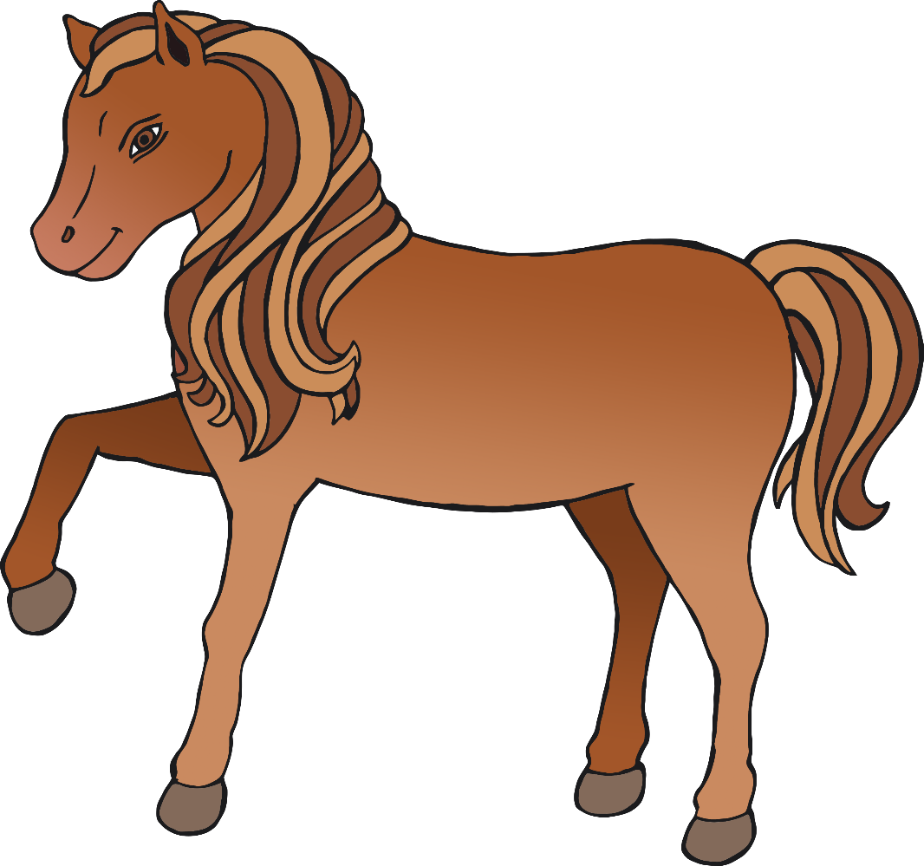

© 2021 Little Owls Resources



m

t

l

h

e

**Horse body parts**

© 2021 Little Owls Resources



mane

tail

leg

hoof

eye

**Horse body parts**

© 2021 Little Owls Resources