**Happy**

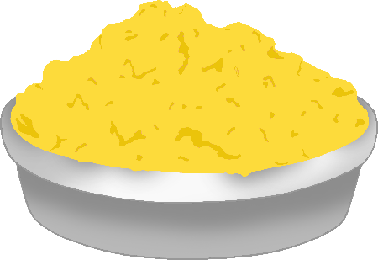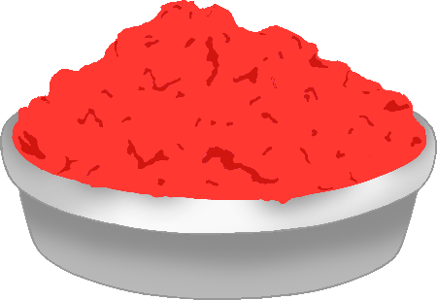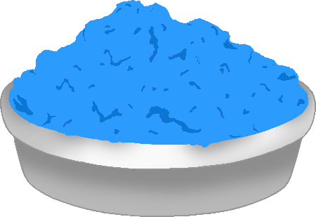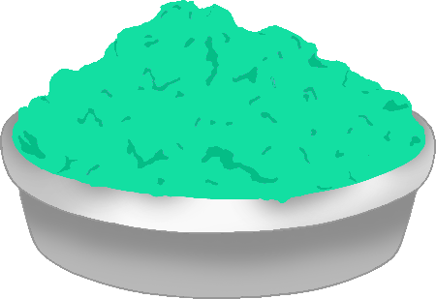

© 2021 Little Owls Resources

होली

**Holi**

**Holi Mubarak**

© 2021 Little Owls Resources

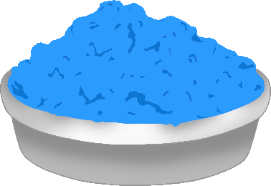

होली मुबारक