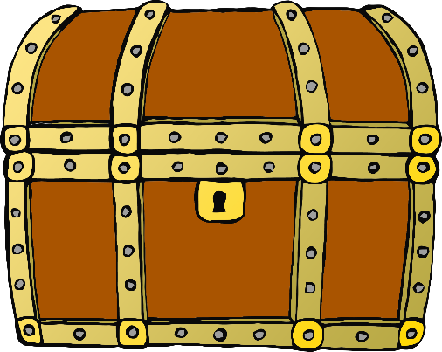

**Hide your special things in the treasure chest!**

What will you hide?

© 2021 Little Owls Resources