Hickory dickory dock.



www.littleowls-premium.com © 2019 Little Owls Resources

www.littleowls-premium.com © 2019 Little Owls Resources

**up**

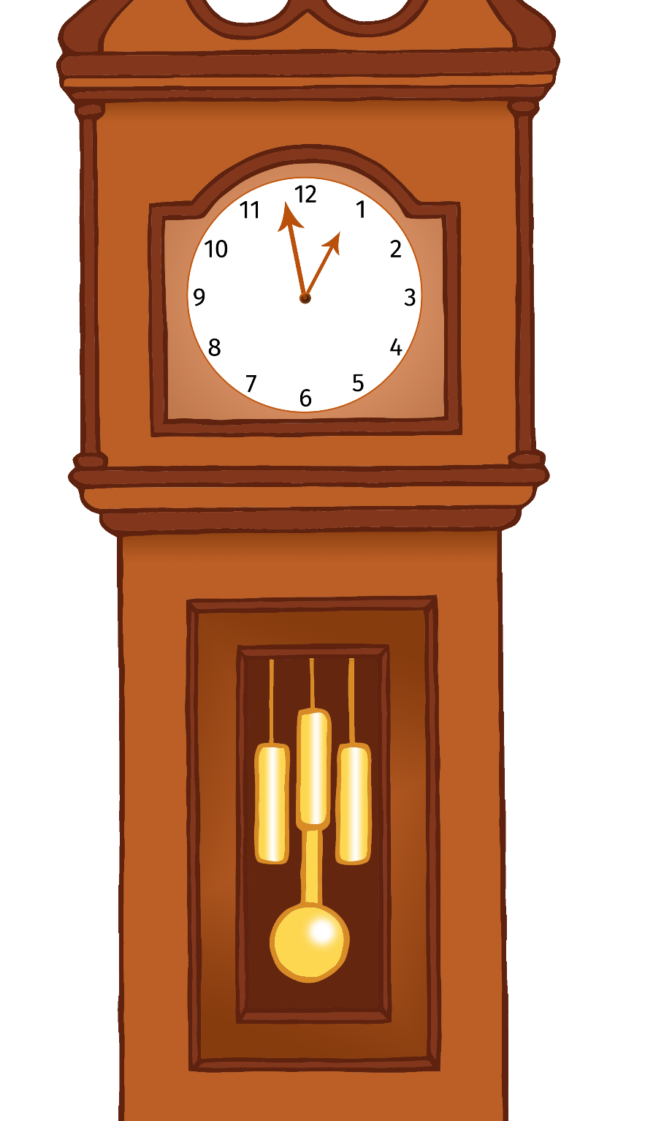

The mouse ran up the clock.

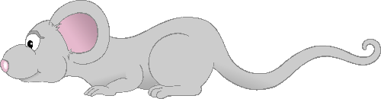

www.littleowls-premium.com © 2019 Little Owls Resources

**Bong!**

The clock struck one!

The mouse ran down.

**down**

www.littleowls-premium.com © 2019 Little Owls Resources

Hickory dickory dock.

www.littleowls-premium.com © 2019 Little Owls Resources