Hickory Dickory Dock

© 2019 Little Owls Resources

Hickory Dickory Dock,

The mouse ran up the clock.

The clock struck one,

The mouse ran down!

Hickory Dickory Dock.

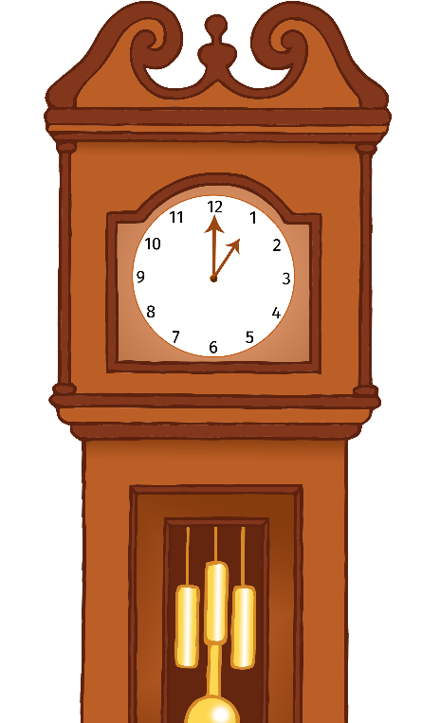

Hickory Dickory Dock

© 2019 Little Owls Resources

Hickory Dickory Dock,

The mouse ran up the clock.

The clock struck one,

The mouse ran down!

Hickory Dickory Dock.



Hickory Dickory Dock

© 2019 Little Owls Resources

Hickory Dickory Dock,

The mouse ran up the clock.

The clock struck one,

The mouse ran down!

Hickory Dickory Dock.



Hickory Dickory Dock

© 2019 Little Owls Resources

Hickory Dickory Dock,

The mouse ran up the clock.

The clock struck one,

The mouse ran down!

Hickory Dickory Dock.

