Hibernation game

Fold here

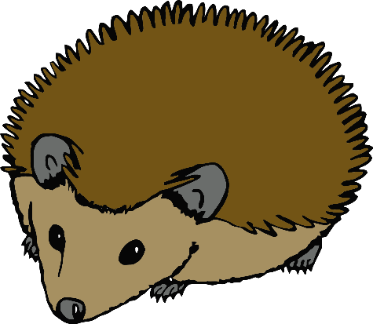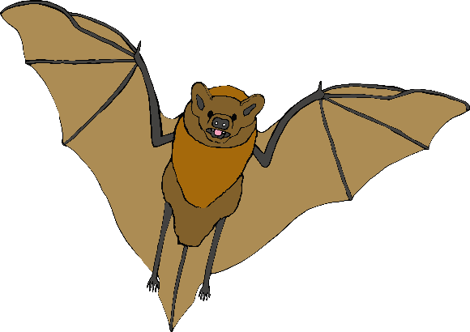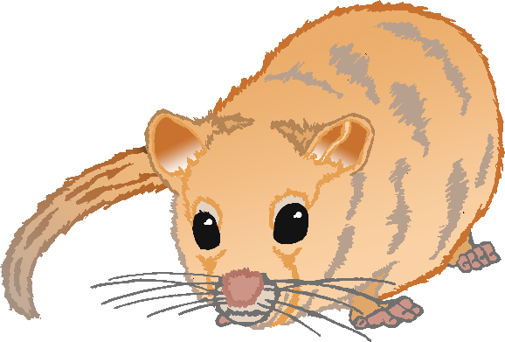

www.littleowlsresources.com © 2019 Little Owls Resources

**Hibernate in Winter**

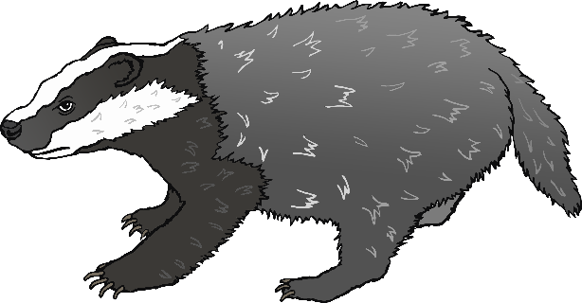

www.littleowlsresources.com © 2019 Little Owls Resources

**Awake in Winter**

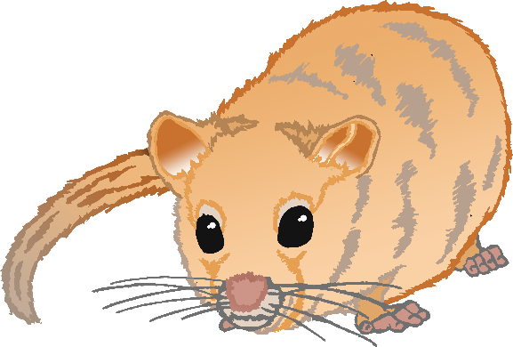

www.littleowlsresources.com

© 2019 Little Owls Resources

www.littleowlsresources.com

© 2019 Little Owls Resources

www.littleowlsresources.com

© 2019 Little Owls Resources

www.littleowlsresources.com

© 2019 Little Owls Resources

www.littleowlsresources.com

© 2019 Little Owls Resources

www.littleowlsresources.com

© 2019 Little Owls Resources

www.littleowlsresources.com

© 2019 Little Owls Resources

www.littleowlsresources.com

© 2019 Little Owls Resources

www.littleowlsresources.com

© 2019 Little Owls Resources

www.littleowlsresources.com

© 2019 Little Owls Resources

www.littleowlsresources.com

© 2019 Little Owls Resources

www.littleowlsresources.com

© 2019 Little Owls Resources