© 2022 Little Owls Resources

© 2022 Little Owls Resources

Hedgehogs are true hibernators. During October and November, they eat as much food as they can in preparation for their long sleep. When the temperature drops to about 5°C they look for a place to hibernate. They will find something to hide under or sometimes collect leaves and twigs to make their own shelter.

Hedgehog

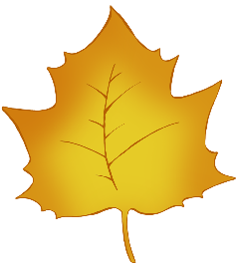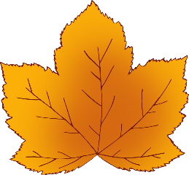

Hibernation

Bat

Bats are true hibernators. They hunt for a good place to hibernate during November, using a hole in a tree, a cave, or the roof of a house. This is called their roost.

Whilst hibernating bats slow down their breathing, so they only take five breaths each minute.



Hibernation

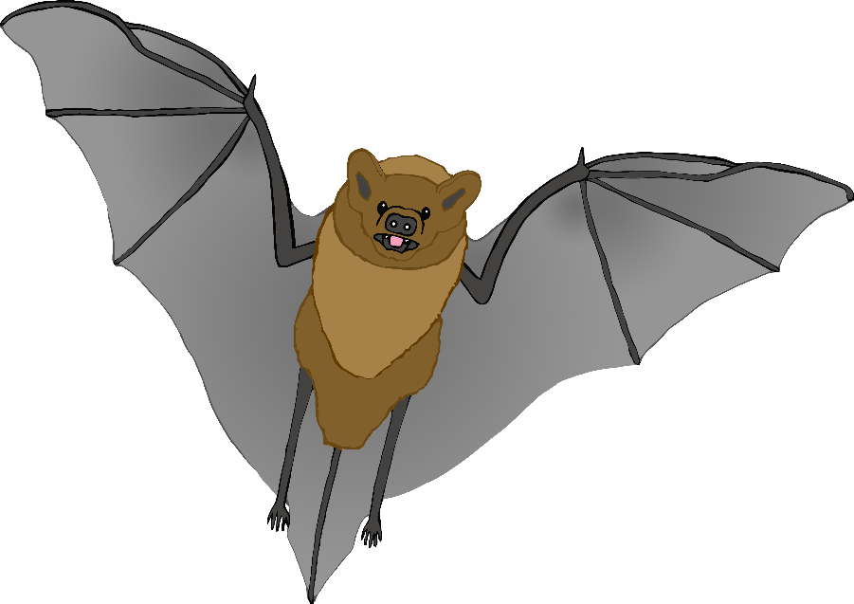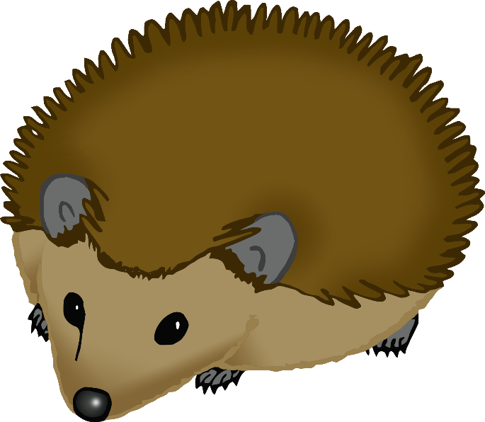

© 2022 Little Owls Resources

© 2022 Little Owls Resources

Dormice are true hibernators, beginning their hibernation between October and November and staying in their deep sleep until April. During this time, they lose half their bodyweight so during the summer they eat a lot!

Dormice hibernate in tiny woven nests under logs or in dead leaves.

Dormouse



Hibernation

Badger

Badgers are **not** true hibernators; they don't sleep for weeks and weeks. However, when the weather is coldest badgers can go into a state called 'torpor' which is a mini hibernation. **Torpor** is a deep sleep for maybe a whole day and night so that they don't need to eat and can stay warm in their home (sett).



Hibernation

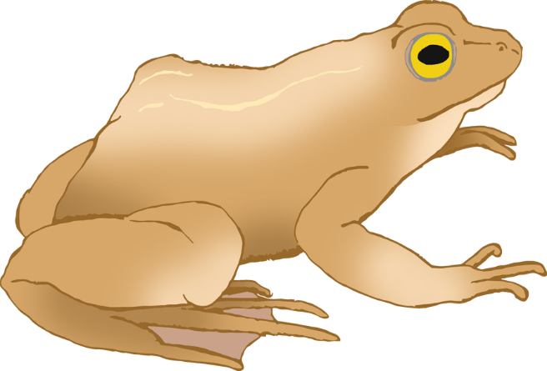

© 2022 Little Owls Resources

© 2022 Little Owls Resources

Grey and red squirrels do **NOT** hibernate. However, during the winter months they are harder to spot as they spend more time staying warm in their homes (dreys). From time to time, they will leave their dreys and dig up nuts they previously buried in the Autumn.

Squirrel



Hibernation

Frog

Frogs are cold-blooded which means their body temperature is affected by the temperature around them. During the winter, frogs enter a state called brumation. **Brumation** is a type of hibernation for reptiles and amphibians where the animal experiences long periods of no movement at all to save energy.

Most frogs brumate on land rather than in the water.



Hibernation

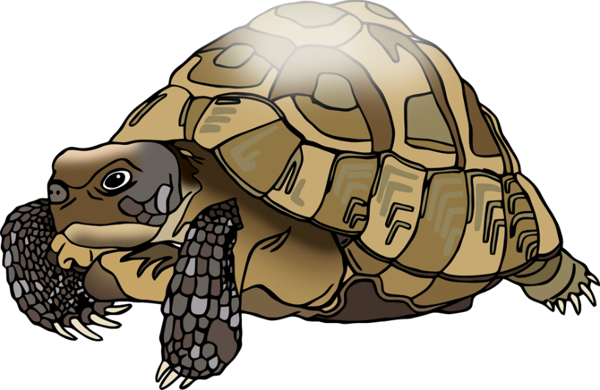

© 2022 Little Owls Resources

© 2022 Little Owls Resources

Slow worms are cold-blooded which means their body temperature is affected by the temperature around them. During the winter, Slow worms enter a state called brumation. **Brumation** is a type of hibernation for reptiles and amphibians where the animal experiences long periods of no movement at all to save energy. Slow worms brumate from October to March.

Slow worm



Hibernation

Tortoise

The most common pet that brumates (hibernates) is a tortoise. Although tortoises can remain safe and warm all year round in someone's home it is best for their health if they brumate every year. **Brumation** is a type of hibernation for reptiles and amphibians where the animal experiences long periods of no movement at all to save energy.



Hibernation

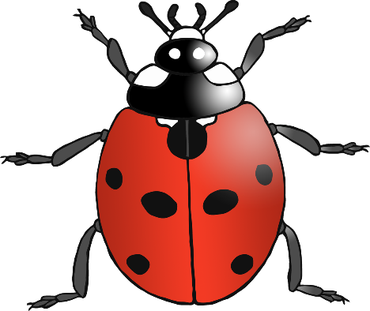

© 2022 Little Owls Resources

© 2022 Little Owls Resources

As insects, ladybirds have a special type of hibernation called diapause. **Diapause** means that whatever stage an insect is at in their life they will pause at that stage if the temperature is too cold. Ladybirds find a safe place to stay completely still over the winter months. When the temperature rises in the spring the ladybirds will wake up and start moving and growing again!

Ladybird



Hibernation

Bumblebee

As insects, bumblebees have a special type of hibernation called diapause. **Diapause** means that whatever stage an insect is at in their life they will pause at that stage if the temperature is too cold. Queen bumblebees find a safe place to stay completely still over the winter months. When the temperature rises in the spring the bumblebees will wake up and start moving and growing again!



Hibernation

© 2022 Little Owls Resources

© 2022 Little Owls Resources

Snail hibernation is called **overwintering**. In winter, snails go where they will be safe and stay dry. Sometimes they climb into pots, up walls or under logs. They pull back into their shell, seal up the opening and wait for warmer weather.

Snail



Hibernation

Earthworm

Before the soil freezes in winter, earthworms burrow up to two metres down into the soil. There they curl themselves up in a slime covered ball sometimes with other earthworms. In this state of hibernation, the earthworms stop themselves from drying out and keep very still to use less energy.



Hibernation