Hibernating Animals

These sheets are for children to record their thoughts, ideas and information about hibernating animals. They are differentiated by amounts of expected writing.

Draw and Write

© 2022 Little Owls Resources

Hibernating Animals

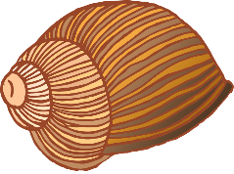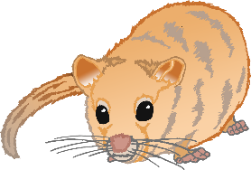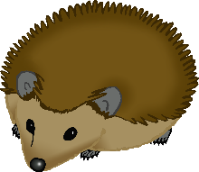

© 2022 Little Owls Resources

Hibernating Animals



© 2022 Little Owls Resources

________­­­­­­­­­­­­­­­­­­­______________________

______________________________

______________________________

______________________________

­______________________________

______________________________

­______________________________

______________________________

Hibernating Animals



© 2022 Little Owls Resources

**________­­­­­­­­­­­­­­­­­­­______________________**

**______________________________**

**______________________________**

**______________________________**

**­______________________________**

**______________________________**

**­______________________________**

Hibernating Animals



© 2022 Little Owls Resources

**________________________________________________________________________________________________________________________________________________________________________________________________________________________________________________________________________________________________________________________________________________________________________________**