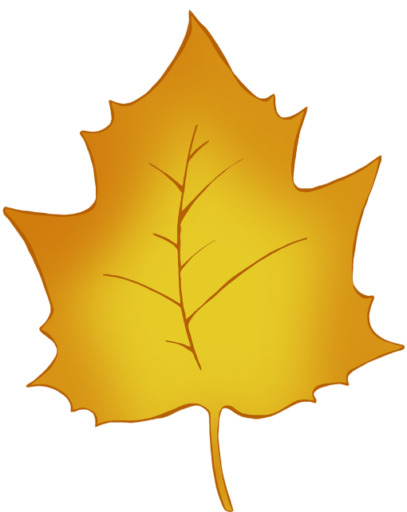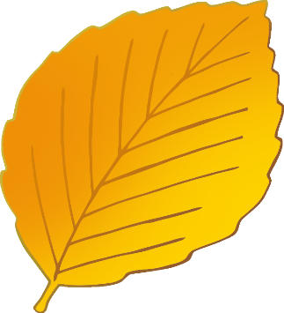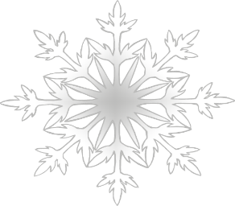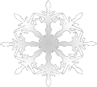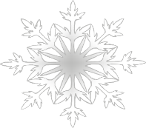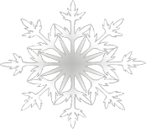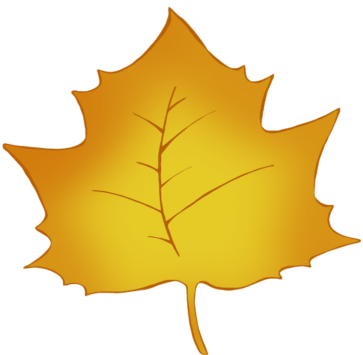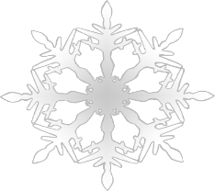

Hibernating

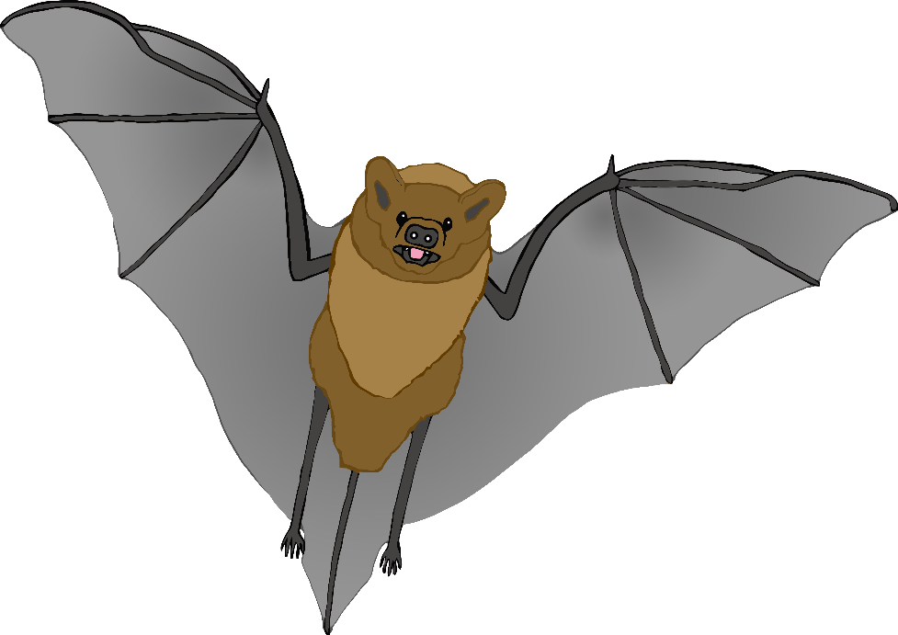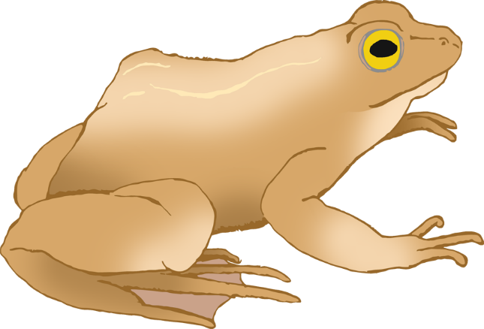



Animals

© 2022 Little Owls Resources

© 2022 Little Owls Resources