Helping Wildlife in Winter

© 2020 Little Owls Resources

Provide shelter

Refill empty food and water

Leave out food

Melt a hole in frozen ponds

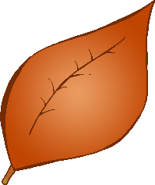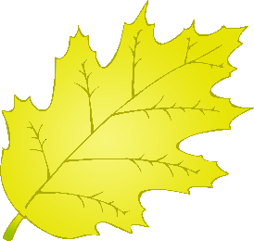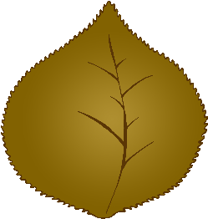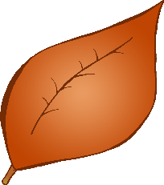

Gather fallen leaves in piles

Leave out fresh water

Refill empty food and water

Leave out food

Provide shelter

Melt a hole in frozen ponds

Leave out fresh water

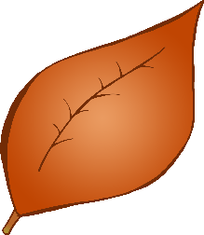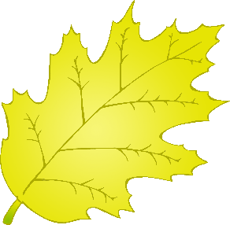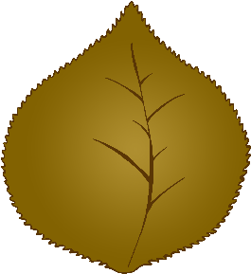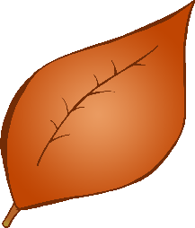

Gather fallen leaves in piles

© 2020 Little Owls Resources

Helping Wildlife in Winter