© 2020 Little Owls Resources

Helping Wildlife

Gather fallen leaves to make homes for hedgehogs and insects.

in Winter

© 2020 Little Owls Resources

Helping Wildlife

Leave out fresh water in a shallow dish.

in Winter

© 2020 Little Owls Resources

Helping Wildlife

Melt a hole in frozen ponds to help wildlife get to the water.

in Winter

© 2020 Little Owls Resources

Helping Wildlife

Provide shelters for wildlife such as a bird box.

in Winter

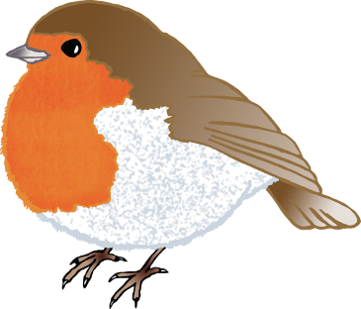

© 2020 Little Owls Resources

Helping Wildlife

Clean and refill empty food and water.

in Winter

© 2020 Little Owls Resources

Helping Wildlife

Leave out a small amount of food to help wildlife through the winter.

in Winter