Helping Wildlife

© 2022 Little Owls Resources

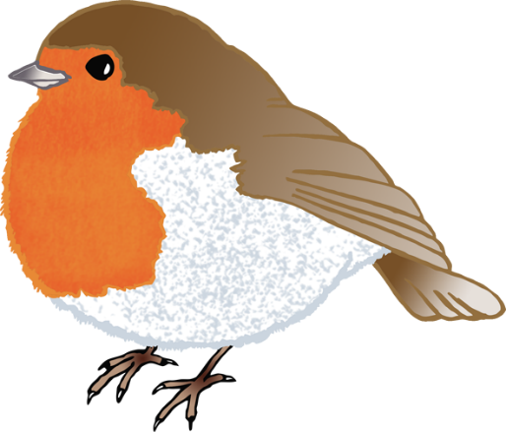

© 2022 Little Owls Resources

in

Winter