I am safe on my scooter!

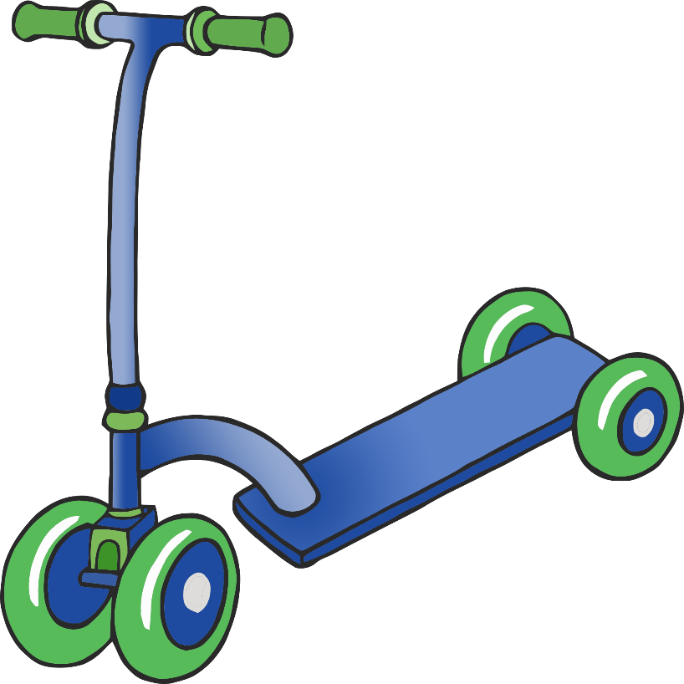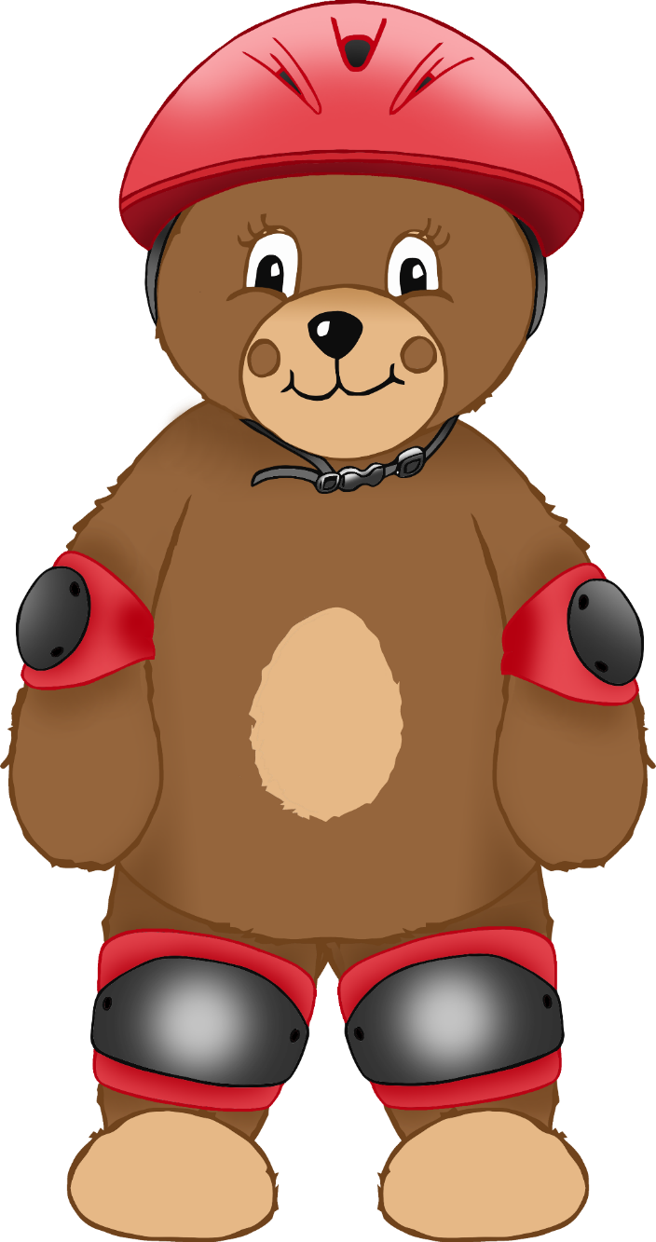

helmet

knee pad

elbow pad

© 2021 Little Owls Resources