I am safe on my scooter!

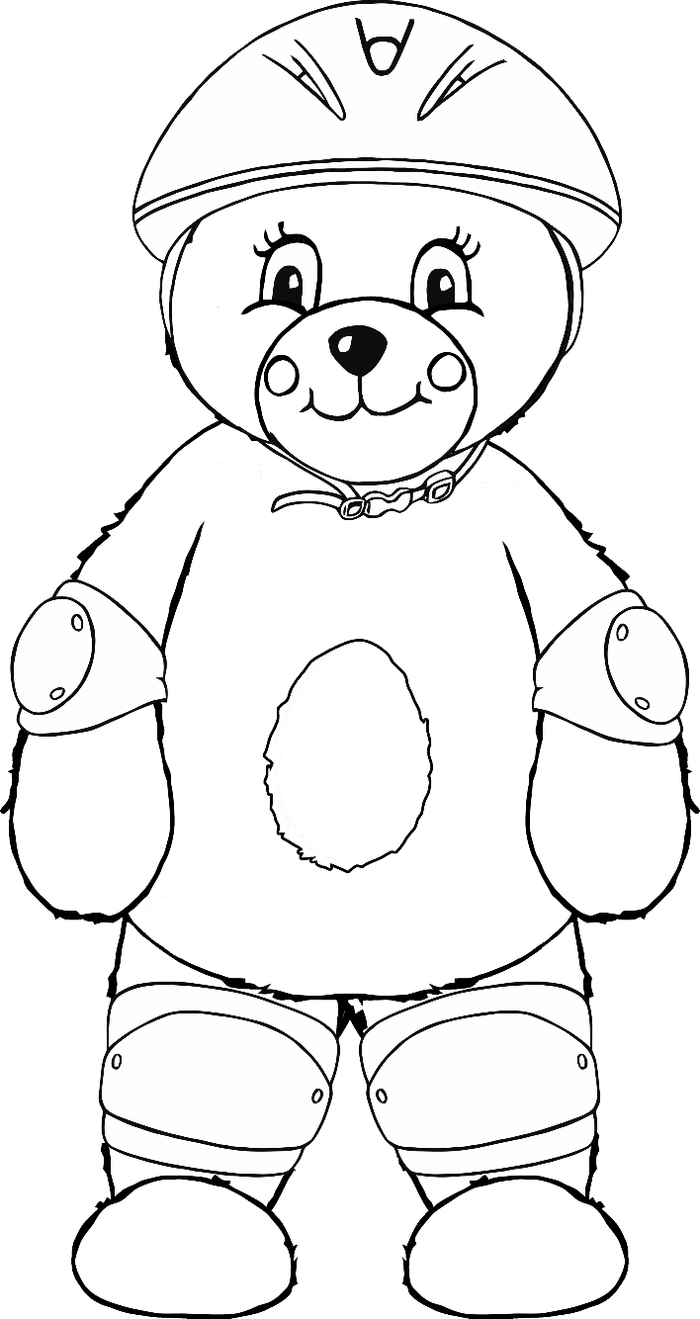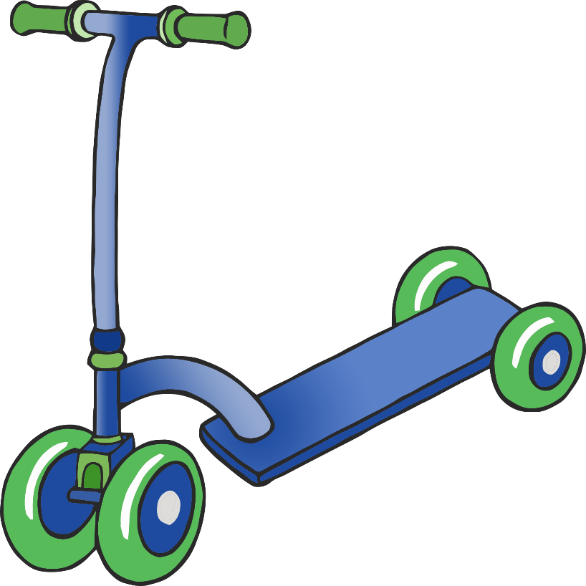

**helmet**

**knee pad**

**elbow pad**

© 2021 Little Owls Resources