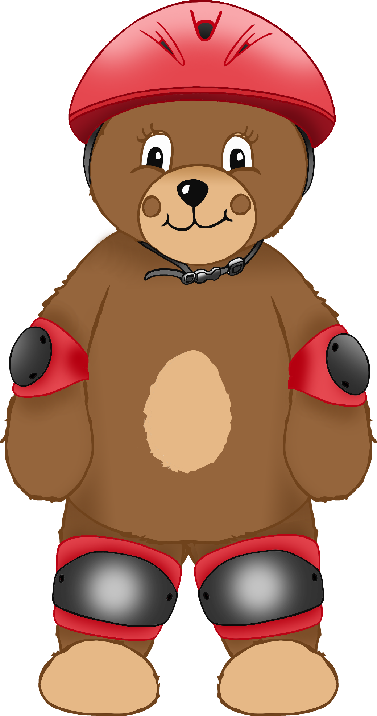

© 2021 Little Owls Resources

knee pad

elbow pad

helmet

I am safe on my bike!