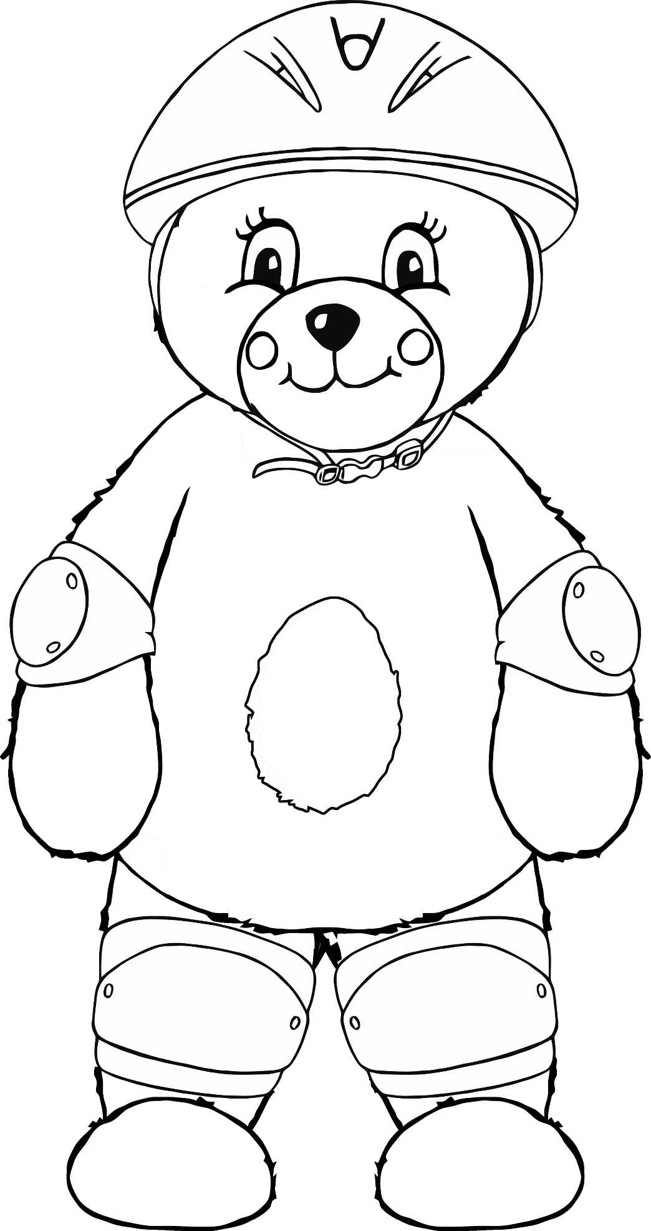

© 2021 Little Owls Resources

**knee pad**

**elbow pad**

**helmet**

I am safe on my bike!