Hedgehogs (1-3)

Subitising

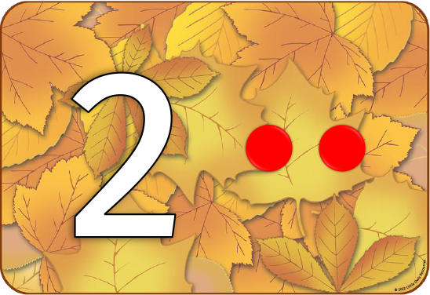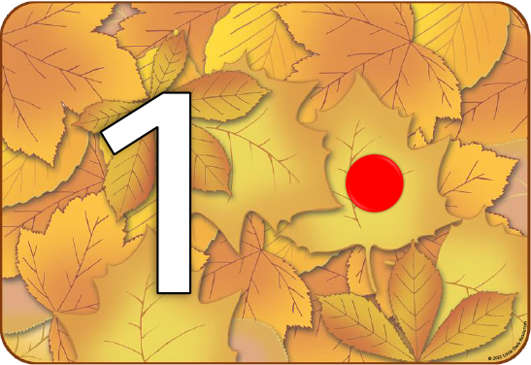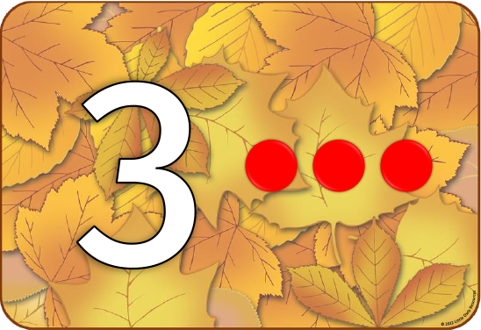

These hedgehogs have random collections of 1-3 dots on them. The children are to be asked to sort them to the correct number pile. At first, they may do this by counting the dots 1:1 but should be encouraged to try and instantly see how many dots are there.

For example:

“That’s two dots isn’t it? We don’t need to count them we already know!”

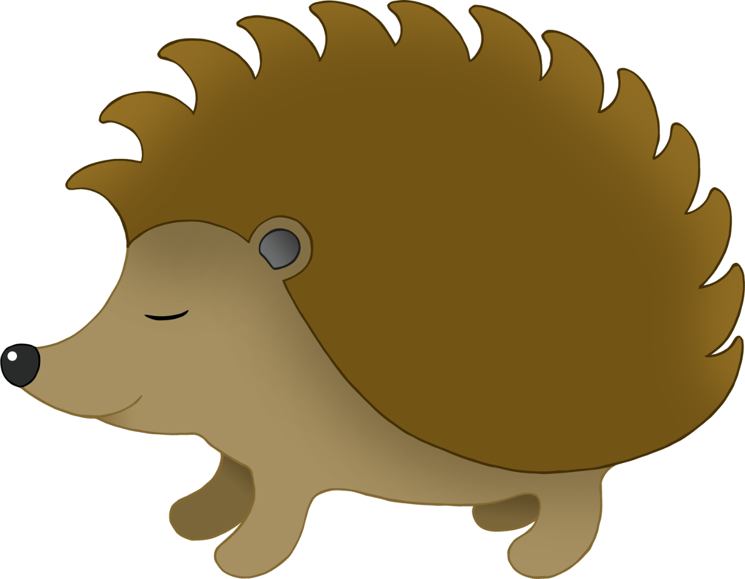

© 2022 Little Owls Resources



© 2022 Little Owls Resources



© 2022 Little Owls Resources



© 2022 Little Owls Resources



© 2022 Little Owls Resources



© 2022 Little Owls Resources



© 2022 Little Owls Resources



© 2022 Little Owls Resources



© 2022 Little Owls Resources



© 2022 Little Owls Resources



© 2022 Little Owls Resources



© 2022 Little Owls Resources

© 2022 Little Owls Resources

© 2022 Little Owls Resources

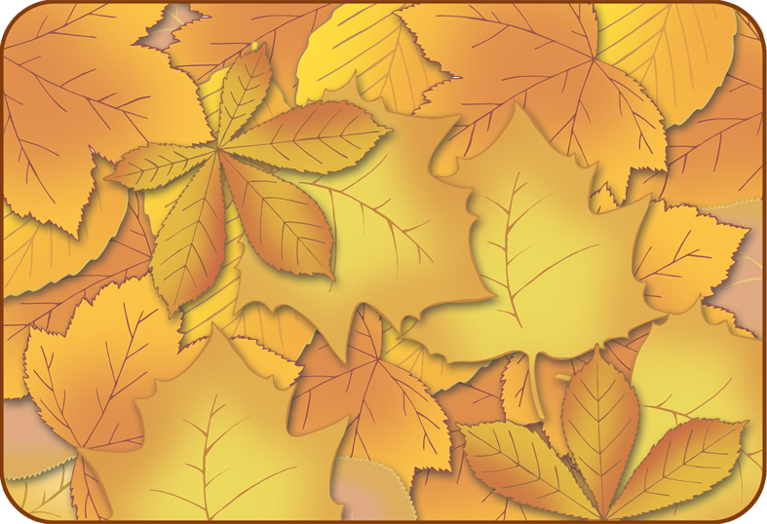

**1**

© 2022 Little Owls Resources



**2**

© 2022 Little Owls Resources

© 2022 Little Owls Resources



**3**