Protecting children - Outdoors

© 2022 Little Owls Resources *Contains public sector information licensed under the Open Government Licence v3.0.*

Extreme Heat

During periods of high temperature, the following steps should be taken:

* children should not take part in vigorous physical activity on very hot days, such as when temperatures are in excess of 30°C
* encourage children playing outdoors to stay in the **shade** as much as possible
* children should wear loose, light-coloured clothing to help keep cool and sunhats with wide brims to avoid sunburn
* use sunscreen (at least factor 15 with UVA protection) to protect skin if children are playing or taking lessons outdoors for more than 20 minutes
* provide children with plenty of water (such as water from a cold tap) and encourage them to drink more than usual when conditions are hot

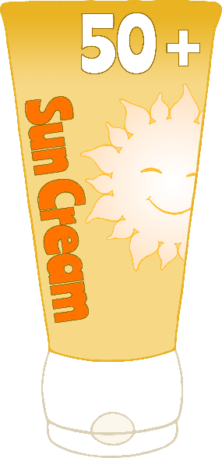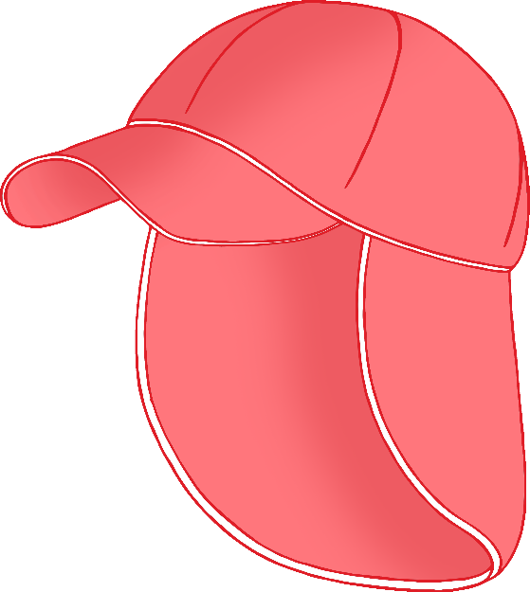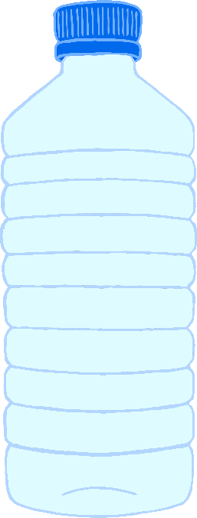

Protecting children - Indoors

© 2022 Little Owls Resources *Contains public sector information licensed under the Open Government Licence v3.0.*

Extreme Heat

During periods of high temperature, the following steps should be taken:

* open windows as early as possible in the morning before children arrive, or preferably overnight to allow stored heat to escape from the building – it is important to check insurance conditions and the need for security if windows are to be left open overnight
* almost close windows when the outdoor air becomes warmer than the air indoors – this should help keep the heat out while allowing adequate ventilation
* use outdoor sun awnings if available, or close indoor blinds or curtains, but do not let them block window ventilation
* keep the use of electric lighting to a minimum
* switch off all electrical equipment, including computers, monitors and printers when not in use – equipment should not be left in ‘standby mode’ as this generates heat
* if possible, use those classrooms or other spaces which are less likely to overheat, and adjust the layout of teaching spaces to avoid direct sunlight on children
* oscillating mechanical fans can be used to increase air movement if temperatures are below 35°C – at temperatures above 35°C fans may not prevent heat-related illness and may worsen dehydration
* if necessary, consider rearranging school start, finish, and play times to avoid teaching during very hot conditions
* encourage children to eat normally and drink plenty of cool water

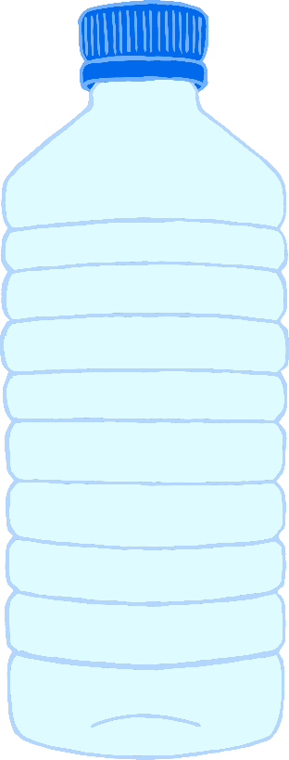

Protecting children - Outdoors

© 2022 Little Owls Resources *Contains public sector information licensed under the Open Government Licence v3.0.*

Extreme Heat

During periods of high temperature, the following steps should be taken:

* children should not take part in vigorous physical activity on very hot days, such as when temperatures are in excess of 30°C
* encourage children playing outdoors to stay in the **shade** as much as possible
* children should wear loose, light-coloured clothing to help keep cool and sunhats with wide brims to avoid sunburn
* use sunscreen (at least factor 15 with UVA protection) to protect skin if children are playing or taking lessons outdoors for more than 20 minutes
* provide children with plenty of water (such as water from a cold tap) and encourage them to drink more than usual when conditions are hot

Protecting children - Indoors

© 2022 Little Owls Resources *Contains public sector information licensed under the Open Government Licence v3.0.*

Extreme Heat

During periods of high temperature, the following steps should be taken:

* open windows as early as possible in the morning before children arrive, or preferably overnight to allow stored heat to escape from the building – it is important to check insurance conditions and the need for security if windows are to be left open overnight
* almost close windows when the outdoor air becomes warmer than the air indoors – this should help keep the heat out while allowing adequate ventilation
* use outdoor sun awnings if available, or close indoor blinds or curtains, but do not let them block window ventilation
* keep the use of electric lighting to a minimum
* switch off all electrical equipment, including computers, monitors and printers when not in use – equipment should not be left in ‘standby mode’ as this generates heat
* if possible, use those classrooms or other spaces which are less likely to overheat, and adjust the layout of teaching spaces to avoid direct sunlight on children
* oscillating mechanical fans can be used to increase air movement if temperatures are below 35°C – at temperatures above 35°C fans may not prevent heat-related illness and may worsen dehydration
* if necessary, consider rearranging school start, finish, and play times to avoid teaching during very hot conditions
* encourage children to eat normally and drink plenty of cool water