**Healthy** & **Unhealthy** Snacks

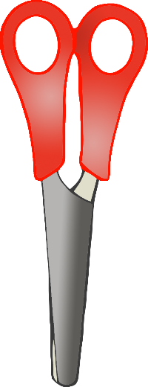

Cut and Stick Activity

Children to cut out the eight snacks and then stick on the correct plate.

© 2020 Little Owls Resources

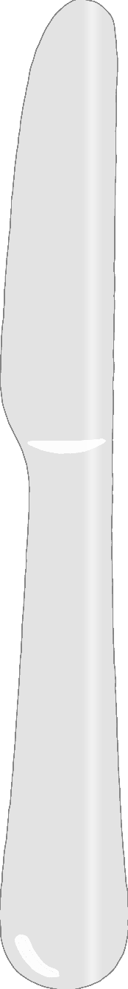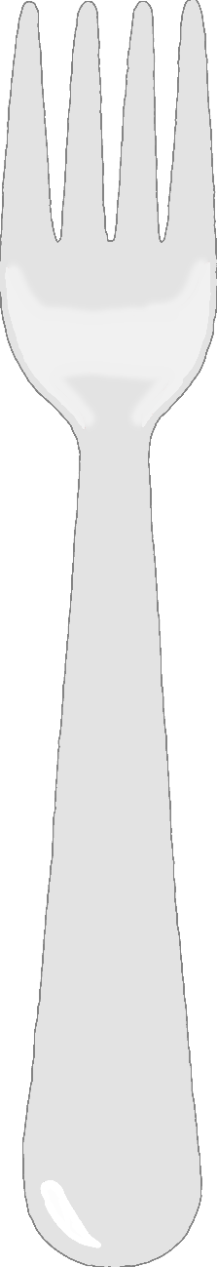

**Healthy Snack**

© 2020 Little Owls Resources



**Unhealthy Snack**

© 2020 Little Owls Resources

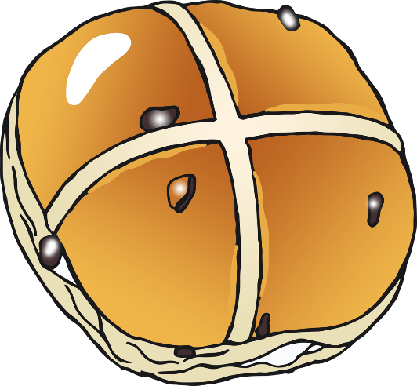

Hot Cross Bun

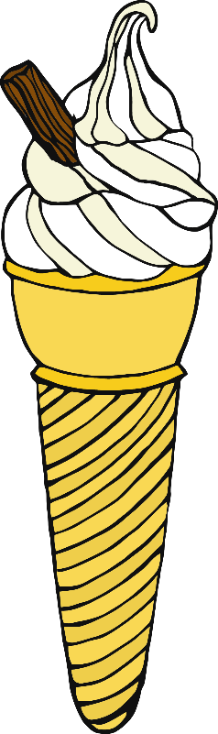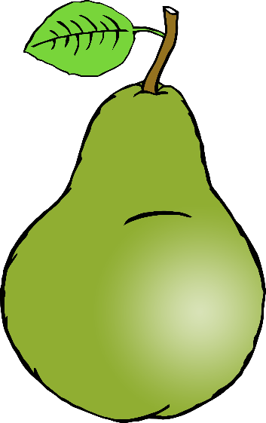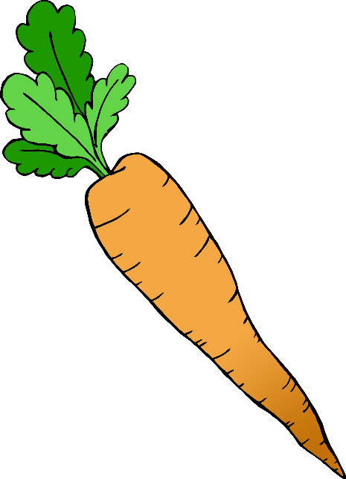

© 2020 Little Owls Resources

Ice-Cream

Carrot

Pear

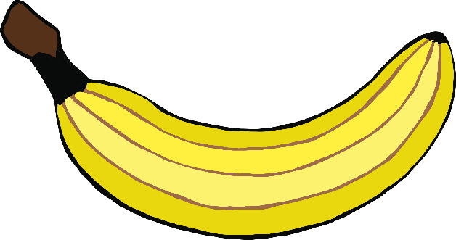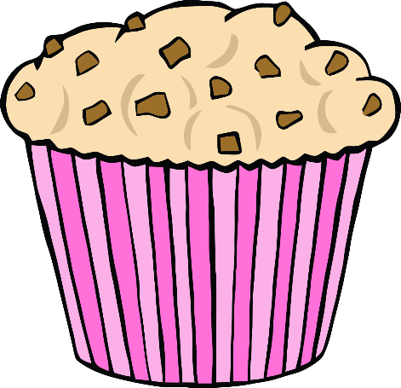

© 2020 Little Owls Resources

Chocolate Pancake

Tomato

Banana

Choc-Chip muffin