Healthy Minds

© 2023 Little Owls Resources

This display pack comprises a two-page banner and a set of cloud shaped headings.

p2-3: Banner

p4-11: Cloud headings (large writing with small images)

p12-19: Cloud headings (small writing with large images)

Display Pack

Healthy

Minds

© 2023 Little Owls Resources

© 2023 Little Owls Resources

Understanding and identifying feelings.

© 2023 Little Owls Resources

Connecting with people and loved ones.

© 2023 Little Owls Resources

Exploring and developing personal interests.

© 2023 Little Owls Resources

Sleep.

Structure and routine.

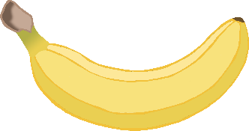

Healthy food and water.

© 2023 Little Owls Resources

Exercise.

Growth mindset.

© 2023 Little Owls Resources

Connecting with nature.

Kindness and helping others.

© 2023 Little Owls Resources

Thankfulness and Gratitude.

*Finding small positives.*

© 2023 Little Owls Resources

Understanding and identifying feelings.

© 2023 Little Owls Resources

Connecting with people and loved ones.

© 2023 Little Owls Resources

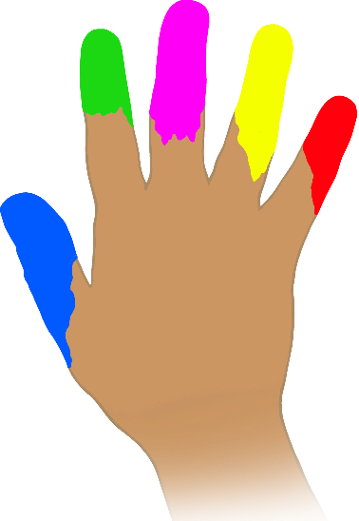

Exploring and developing personal interests.

© 2023 Little Owls Resources

Sleep.

Structure and routine.

© 2023 Little Owls Resources

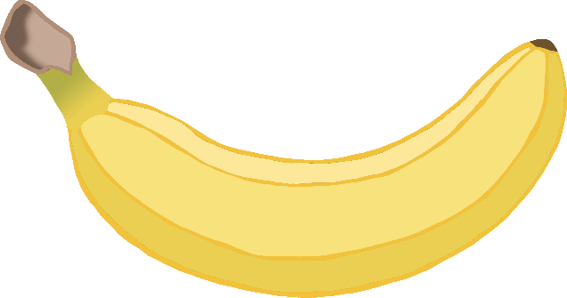

Exercise.

Healthy food and water.

© 2023 Little Owls Resources

© 2023 Little Owls Resources

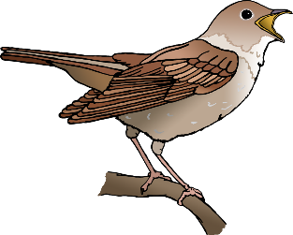

Growth mindset.

Connecting with nature.

Kindness and helping others.

© 2023 Little Owls Resources

© 2023 Little Owls Resources

Thankfulness and Gratitude.

*Finding small positives.*