© 2021 Little Owls Resources

**Head, shoulders, knees and toes,**

**knees and toes**

**Head, shoulders, knees and toes,**

**knees and toes**

**And eyes and ears and mouth and nose**

**Head, shoulders, knees and toes,**

**knees and toes.**

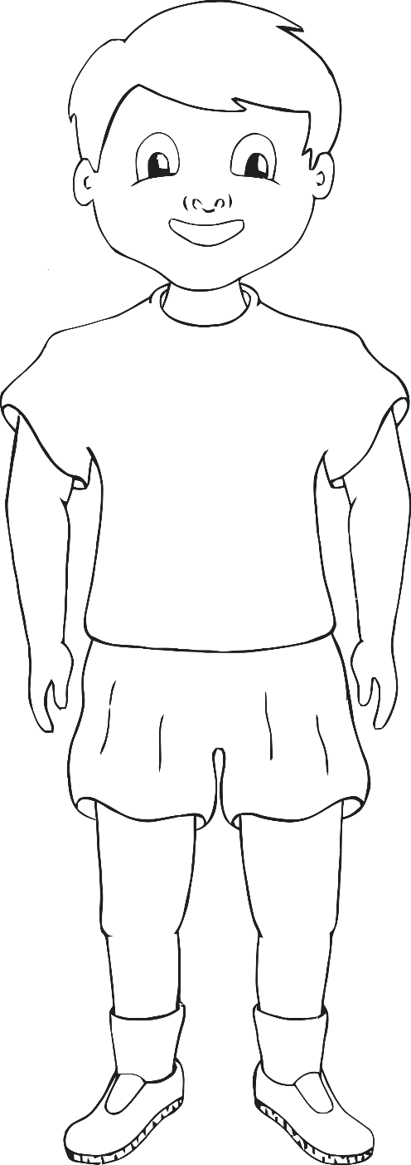

**Shoulders**

**Head**

**Toes**

Head, Shoulders,

Knees and Toes

**Knees**

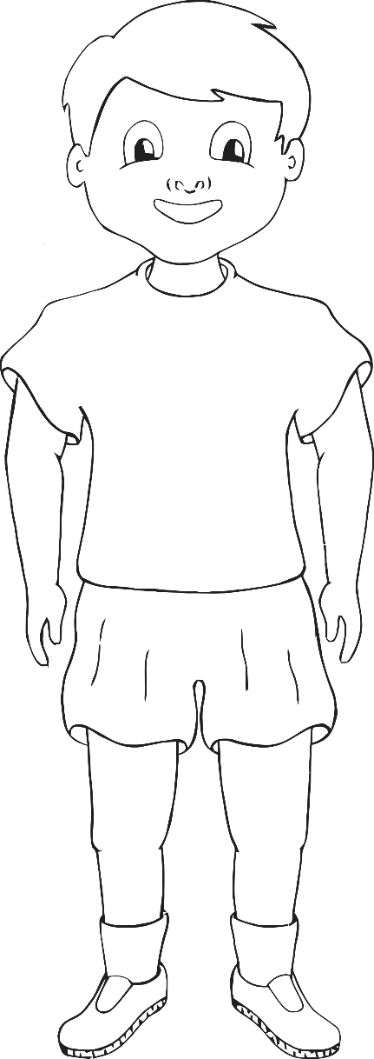

Head, Shoulders, Knees and Toes

**Head**

© 2021 Little Owls Resources

**Head, shoulders, knees and toes,**

**knees and toes**

**Head, shoulders, knees and toes,**

**knees and toes**

**And eyes and ears and mouth and nose**

**Head, shoulders, knees and toes,**

**knees and toes.**

**Toes**

**Knees**

**Shoulders**