© 2019 Little Owls Resources

© 2019 Little Owls Resources

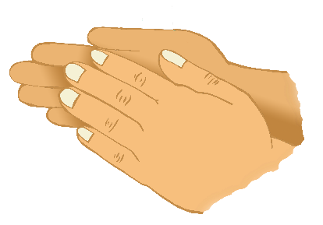

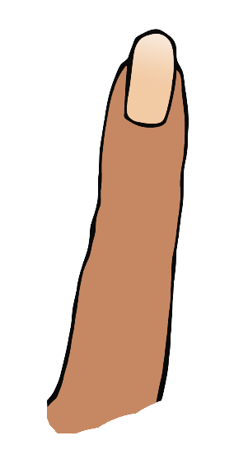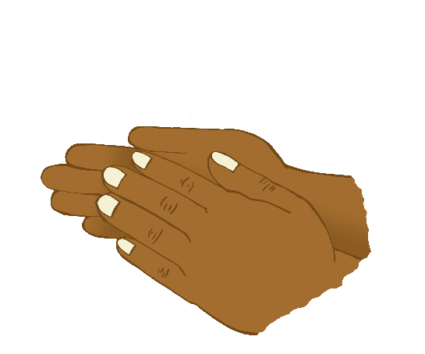

© 2019 Little Owls Resources

© 2019 Little Owls Resources



© 2019 Little Owls Resources

© 2019 Little Owls Resources

**We are!**

© 2019 Little Owls Resources