If you’re happy and you know it…

© 2019 Little Owls Resources

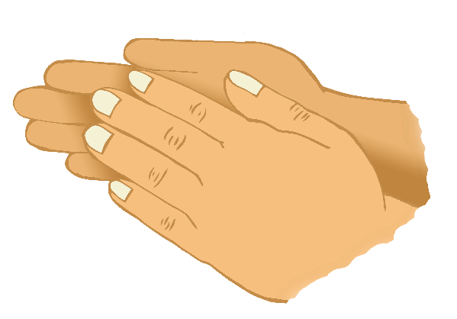

If you're happy and you know it, clap your hands!

If you're happy and you know it, clap your hands!

If you're happy and you know it,

and you really want to show it,

If you're happy and you know it, clap your hands!

If you’re happy and you know it…

© 2019 Little Owls Resources



If you're happy and you know it, clap your hands!

If you're happy and you know it, clap your hands!

If you're happy and you know it,

and you really want to show it,

If you're happy and you know it, clap your hands!

If you’re happy and you know it…

© 2019 Little Owls Resources



If you're happy and you know it, clap your hands!

If you're happy and you know it, clap your hands!

If you're happy and you know it,

and you really want to show it,

If you're happy and you know it, clap your hands!

If you’re happy and you know it…

© 2019 Little Owls Resources



If you're happy and you know it, clap your hands!

If you're happy and you know it, clap your hands!

If you're happy and you know it,

and you really want to show it,

If you're happy and you know it, clap your hands!