If you’re happy and you know it…

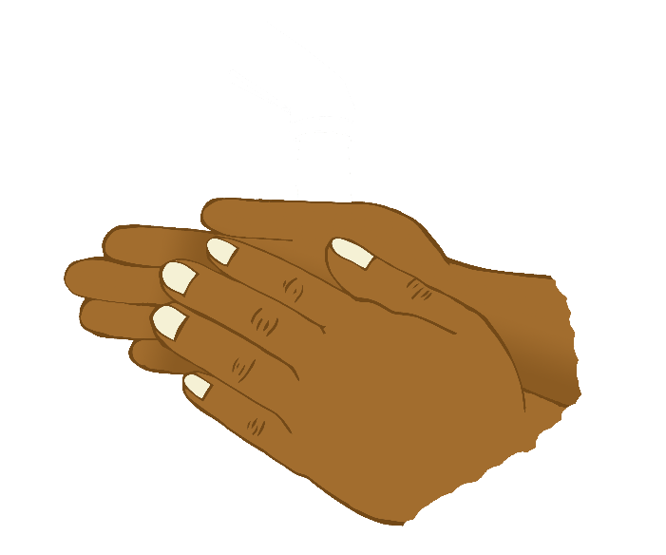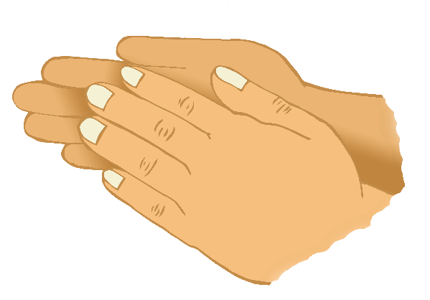

If you're happy and you know it, clap your hands!

If you're happy and you know it, clap your hands!

If you're happy and you know it,

and you really want to show it,

If you're happy and you know it, clap your hands!

* If you're happy and you know it, stamp your feet!
* If you're happy and you know it, nod your head!
* If you're happy and you know it, touch your ear!
* If you're happy and you know it, turn around!
* If you're happy and you know it, touch your nose!
* If you're happy and you know it, say "we are!"