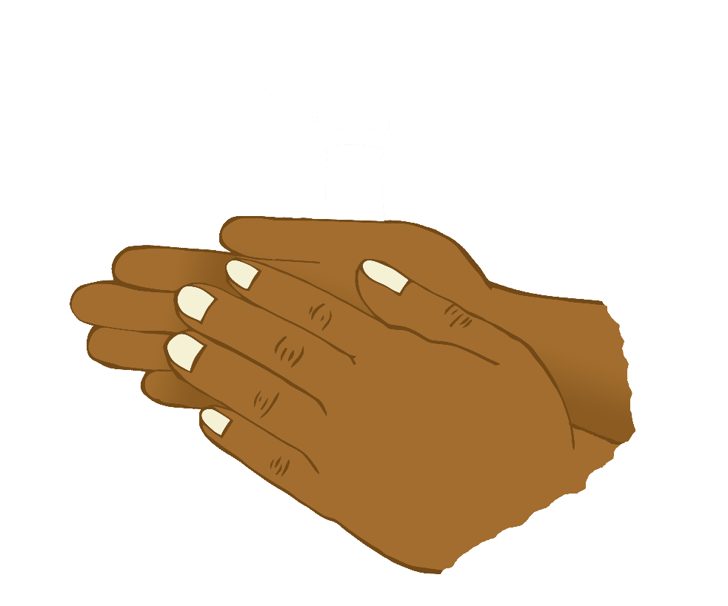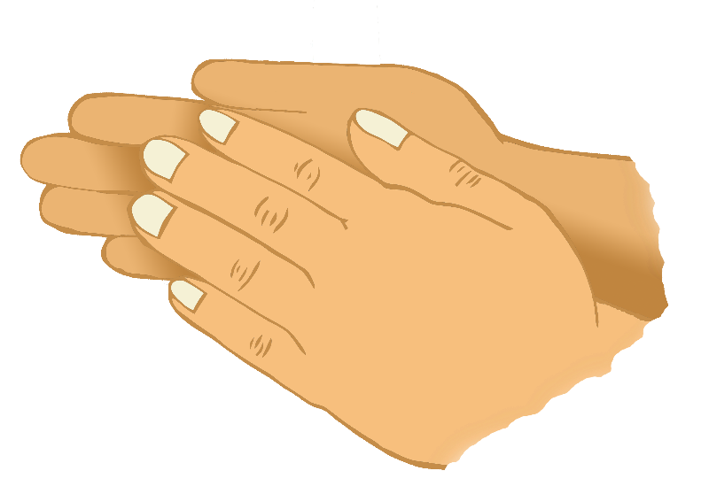

If you’re happy and you know it

clap your hands…

www.littleowls-premium.com © 2019 Little Owls Resources

If you’re happy and you know it

stamp your feet…

www.littleowls-premium.com © 2019 Little Owls Resources

If you’re happy and you know it

nod your head…

www.littleowls-premium.com © 2019 Little Owls Resources

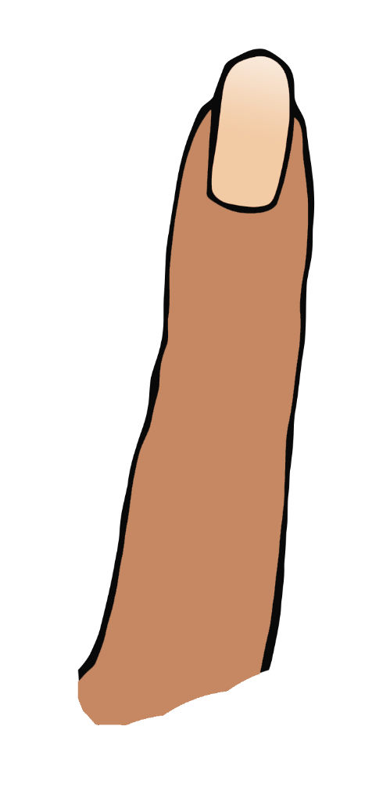

If you’re happy and you know it

touch your ear…

www.littleowls-premium.com © 2019 Little Owls Resources



If you’re happy and you know it

turn around…

www.littleowls-premium.com © 2019 Little Owls Resources

If you’re happy and you know it

touch your nose…

www.littleowls-premium.com © 2019 Little Owls Resources

**We are!**

If you’re happy and you know it

say “we are!”…

www.littleowls-premium.com © 2019 Little Owls Resources