**Happy Holidays**

© 2019 Little Owls Resources

Happy

Holidays

© 2019 Little Owls Resources

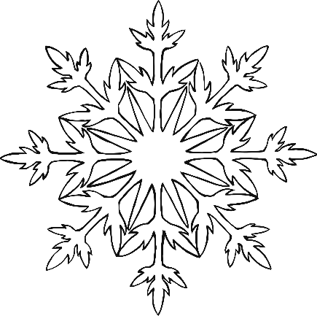

Happy

Holidays!

© 2019 Little Owls Resources

Happy

Holidays

© 2019 Little Owls Resources

Happy

Holidays

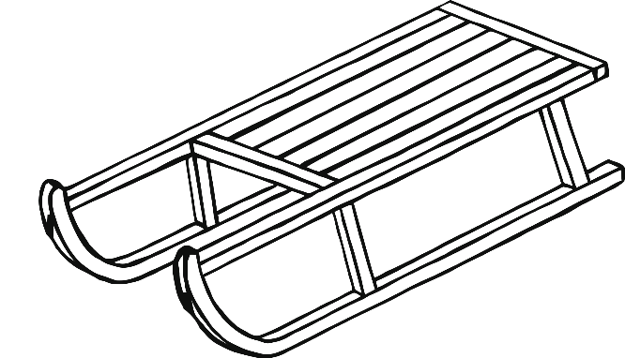

© 2019 Little Owls Resources

Happy

Holidays

© 2019 Little Owls Resources

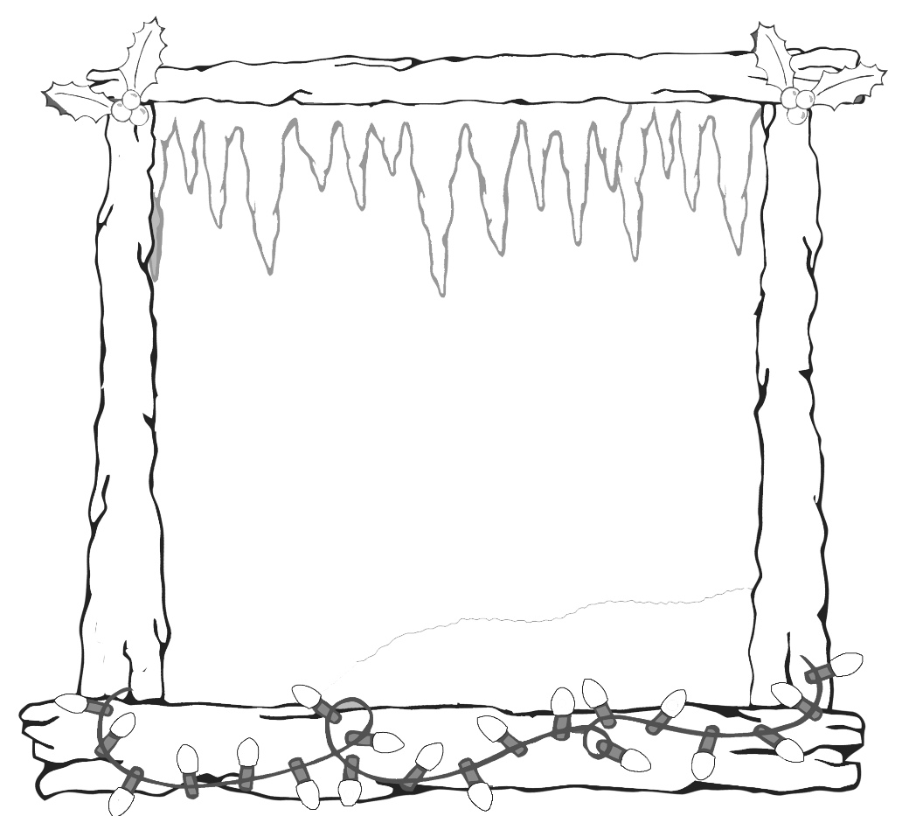

Happy

Holidays

© 2019 Little Owls Resources

Happy

Holidays

© 2019 Little Owls Resources

© 2019 Little Owls Resources

Happy Holidays

© 2019 Little Owls Resources

Happy

Holidays