Hanukkah Word Mat

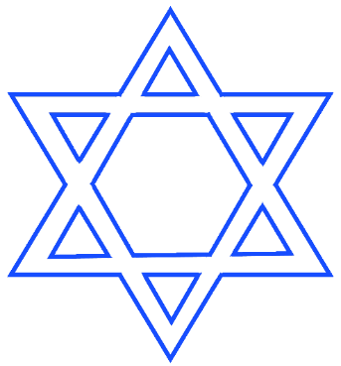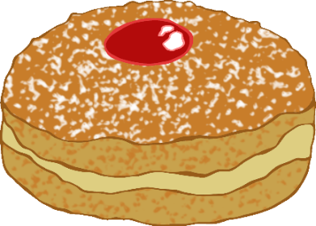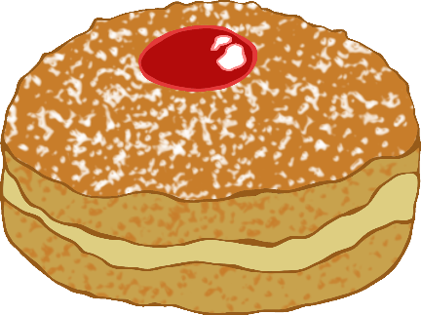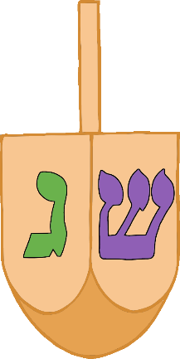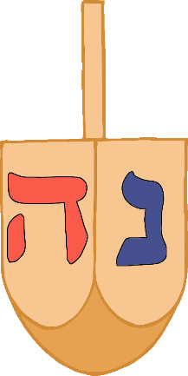

Star of David

Menorah

Latkes

Candle

Sufganiyot

Dreidel

Oil Lamp

Gelt

© 2020 Little Owls Resources