Menorah

Menorah

© 2020 Little Owls Resources

© 2020 Little Owls Resources

Menorah

Menorah

© 2020 Little Owls Resources

© 2020 Little Owls Resources

Dreidel

Dreidel

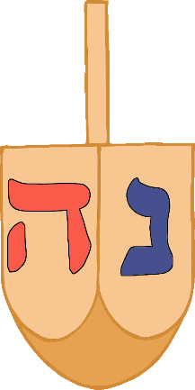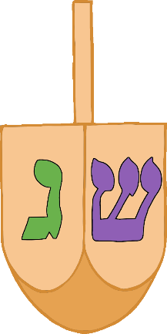

© 2020 Little Owls Resources

© 2020 Little Owls Resources



© 2020 Little Owls Resources

© 2020 Little Owls Resources

Dreidel

Dreidel

Latkes

Latkes

© 2020 Little Owls Resources

© 2020 Little Owls Resources

Latkes

Latkes

© 2020 Little Owls Resources

© 2020 Little Owls Resources

Oil Lamp

Oil Lamp

© 2020 Little Owls Resources

© 2020 Little Owls Resources

Oil Lamp

Oil Lamp

© 2020 Little Owls Resources

© 2020 Little Owls Resources

Sufganiyot

Sufganiyot

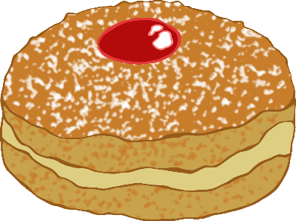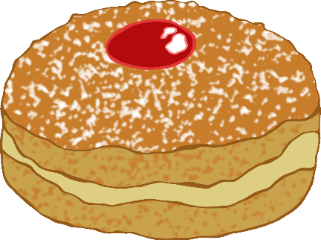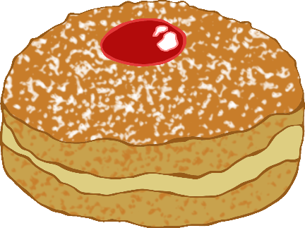

© 2020 Little Owls Resources

© 2020 Little Owls Resources

Sufganiyot

Sufganiyot



© 2020 Little Owls Resources

© 2020 Little Owls Resources

Star of David

Star of David

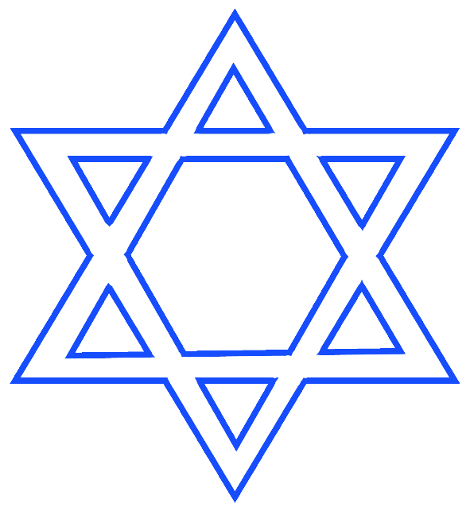

© 2020 Little Owls Resources

© 2020 Little Owls Resources



Star of David

Star of David

© 2020 Little Owls Resources

© 2020 Little Owls Resources

Candle

Candle

© 2020 Little Owls Resources

© 2020 Little Owls Resources

Candle

Candle

© 2020 Little Owls Resources

© 2020 Little Owls Resources

Gelt

Gelt

© 2020 Little Owls Resources

© 2020 Little Owls Resources

Gelt

Gelt

© 2020 Little Owls Resources

© 2020 Little Owls Resources

Challah Bread

Challah Bread

© 2020 Little Owls Resources

© 2020 Little Owls Resources

© 2020 Little Owls Resources

© 2020 Little Owls Resources

Challah Bread

Challah Bread