1

2

3

4

5

6

7

8

9

10

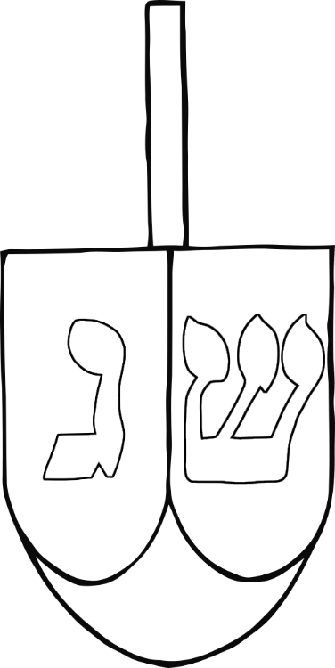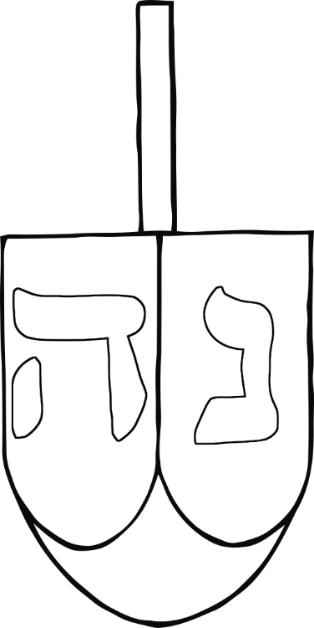

1

2

3

4

5



1

2

3

4

5

6

7

8

9

10

1

2

3

4

5

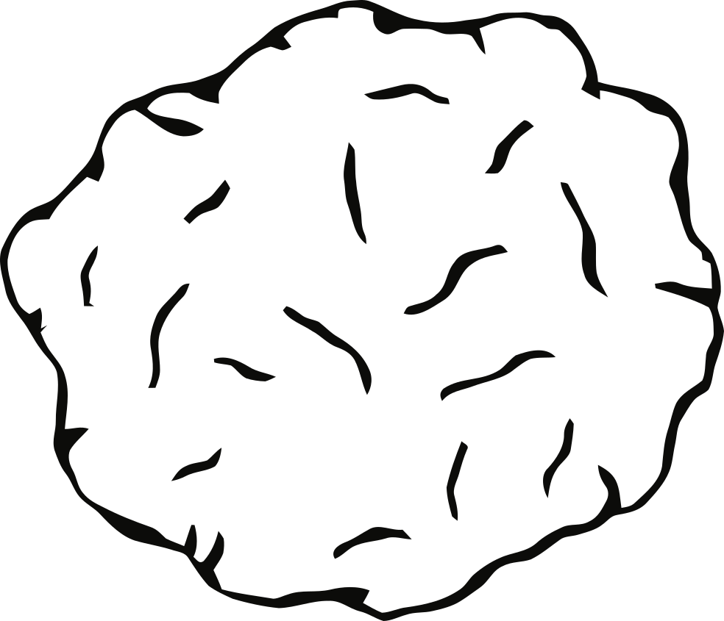

1

2

3

4

5

6

7

8

9

10



5

4

3

2

1

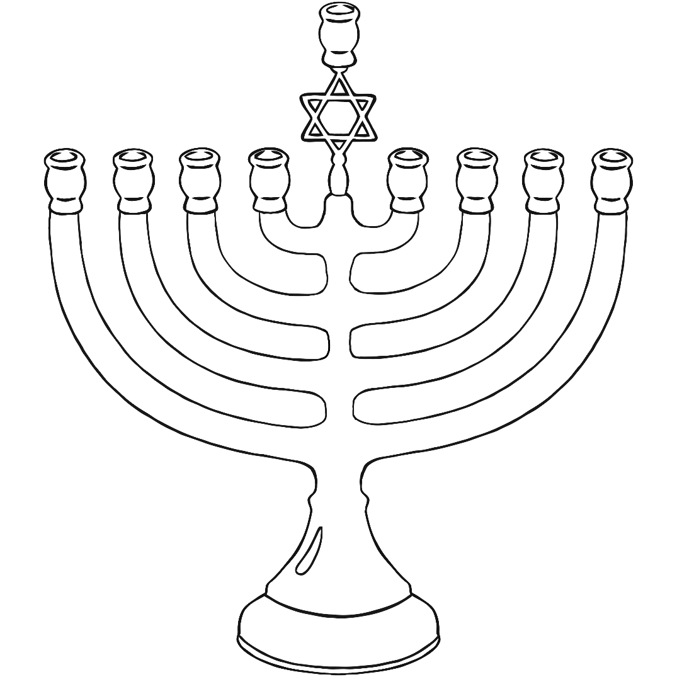

10

9

8

7

6

5

4

3

2

1



1

2

3

4

5

1

2

3

4

5

6

7

8

9

10

5

4

3

2

1