Happy Hanukkah

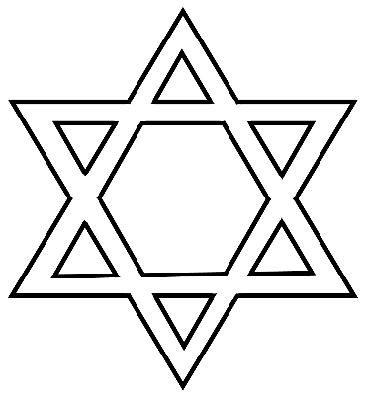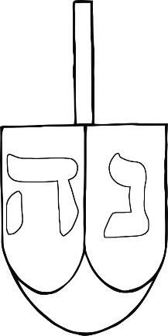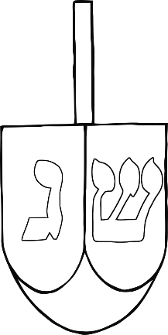

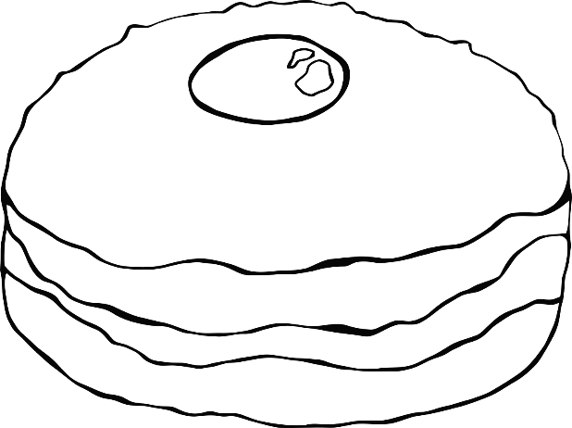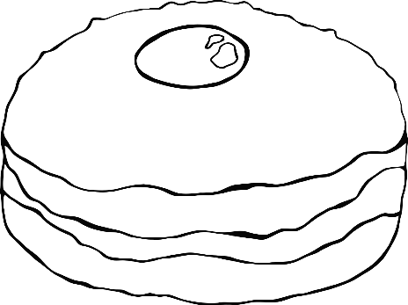

Jam doughnuts for Hanukkah

**Sufganiyot**

**Oil Lamp**

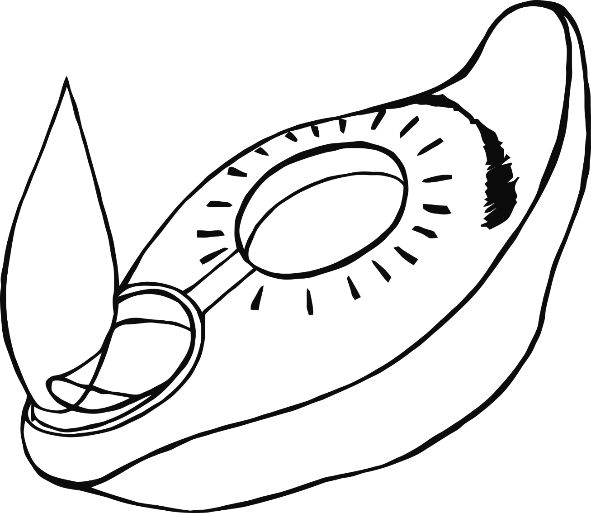

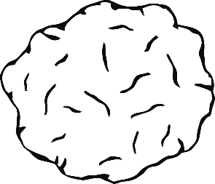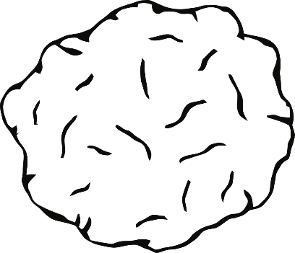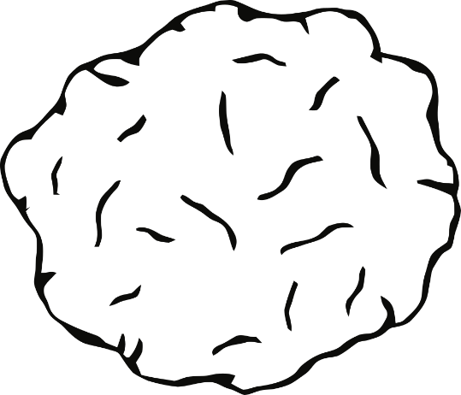

Potato pancakes for Hanukkah

**Latkes**

**Menorah**

**Dreidel**



Spinning top game for Hanukkah

**Gelt**

Nun

Gimel

Hey

Shin

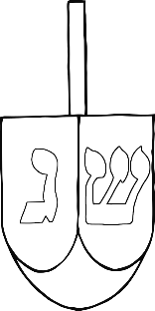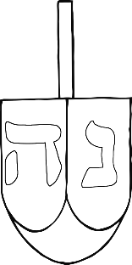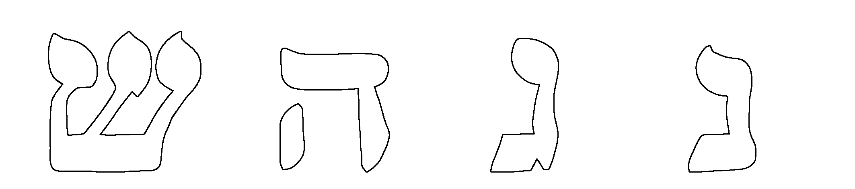

“A great miracle occurred there.”

