Happy

Hanukkah!

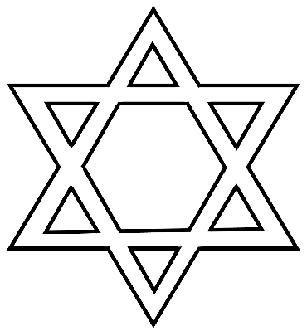

© 2020 Little Owls Resources

Happy

Hanukkah

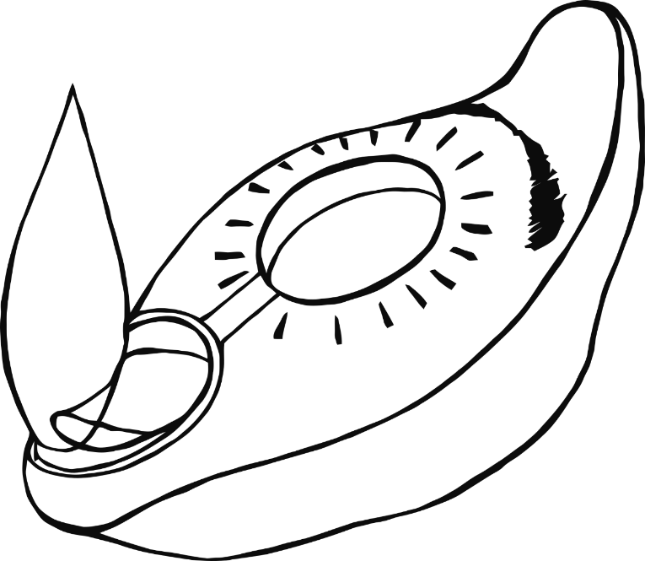

© 2020 Little Owls Resources

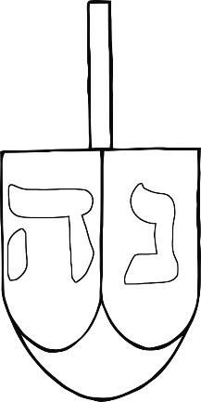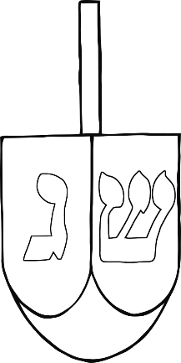

Happy

Hanukkah

© 2020 Little Owls Resources

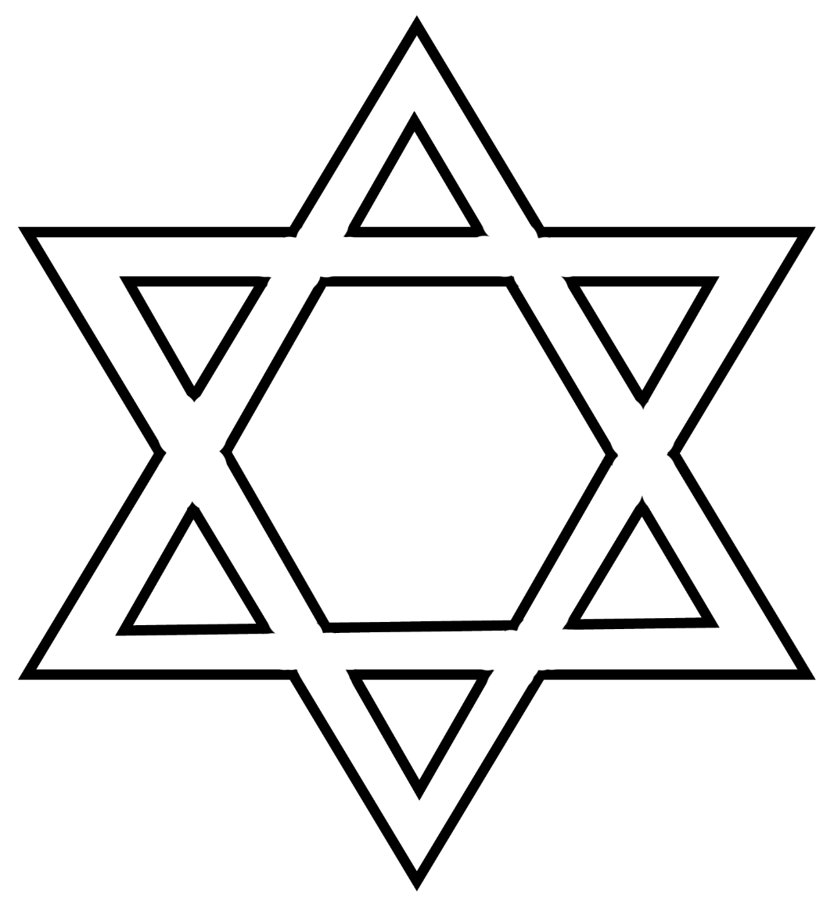

Happy

Hanukkah

© 2020 Little Owls Resources

Happy

Hanukkah

© 2020 Little Owls Resources

Happy

Hanukkah

© 2020 Little Owls Resources

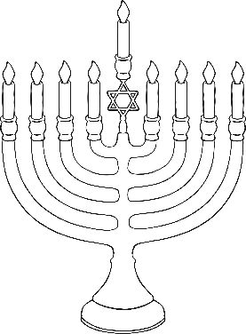

Happy Hanukkah

© 2020 Little Owls Resources

Love & Light

© 2020 Little Owls Resources

wls Resources

Love & Light

© 2020 Little Owls Resources

Happy

Hanukkah

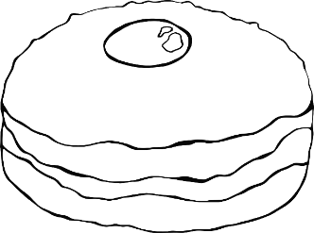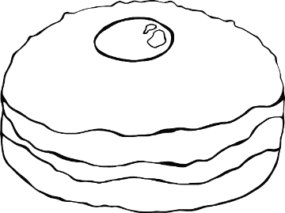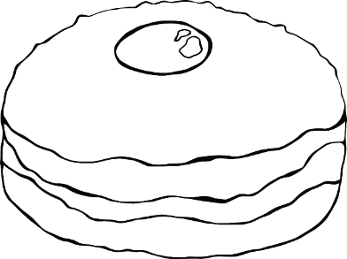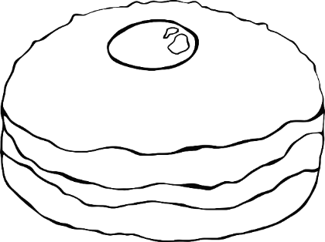

© 2020 Little Owls Resources

© 2020 Little Owls Resources

Happy Hanukkah

