**Hanukkah**

**Be Proud!**

During the first Hanukkah a group of Jewish warriors called the Maccabees reclaimed a Temple that had been taken from them. They then proudly lit the candles of the menorah as a sign of their faith.

This activity is designed to get the children to think about what pride is and identify something about themselves that they are proud of.

Are they kind? Are they helpful? Are they a good friend?

There are three differentiated sheets for children to either draw, draw and write or just write about an aspect of themselves that makes them proud.

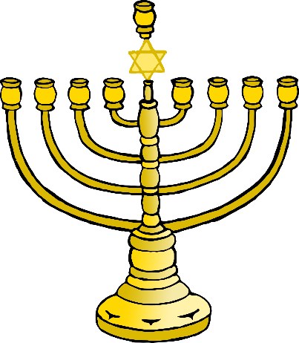

© 2019 Little Owls Resources

**Be Proud!**

Draw something about yourself that makes you proud!

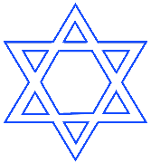

© 2019 Little Owls Resources

**Be Proud!**

Draw and write something about yourself that makes you proud!



______________________________________________________



© 2019 Little Owls Resources

**Be Proud!**

Write something about yourself that makes you proud!



______________________________________________________

________________________________________________________________________