**All About Me**

Handprint – Name - Picture

As well as part of an ‘All About Me’ topic, this sheet could be used at the start of a child’s time at a particular setting. It can then be referred to with the child at a later time to show them how much they have improved in writing their name, drawing themselves or even how much bigger their hand is!

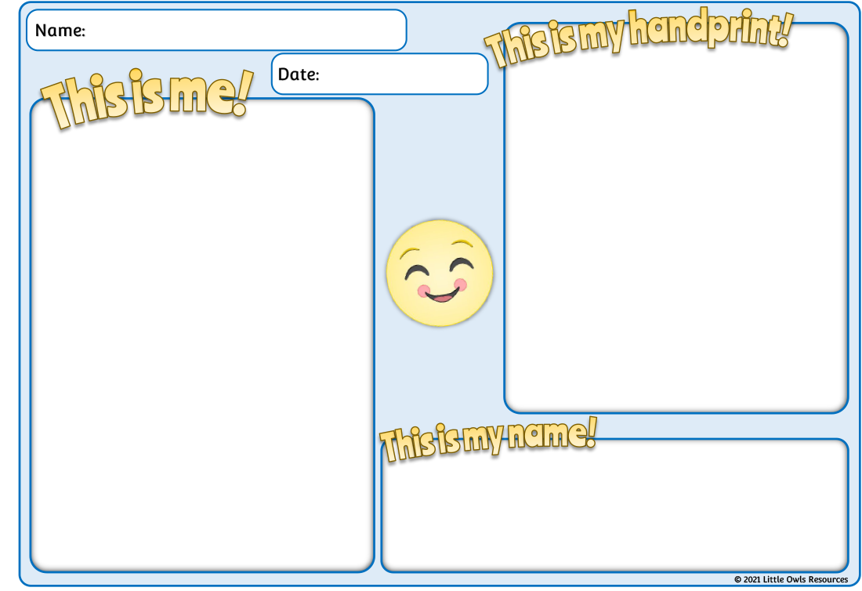

L i l l **y**

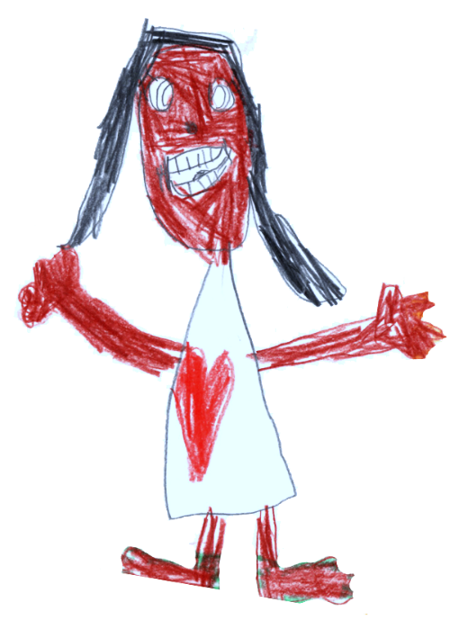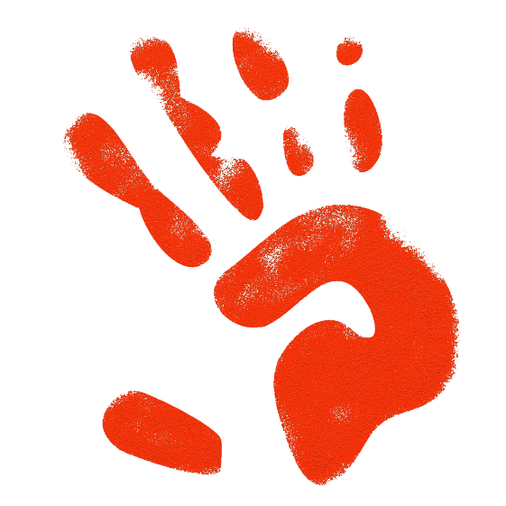

© 2021 Little Owls Resources

**This is my handprint!**

**This is me!**

Name:

Date:

**This is my name!**

© 2021 Little Owls Resources

**This is my handprint!**

**This is me!**

**This is my name!**

Name:

Date:



© 2021 Little Owls Resources

**This is my handprint!**

**This is me!**

**This is my name!**

Name:

Date:



© 2021 Little Owls Resources

**This is my handprint!**

**This is me!**

**This is my name!**

Name:

Date:



© 2021 Little Owls Resources

**This is my handprint!**

**This is me!**

**This is my name!**

Name:

Date:



© 2021 Little Owls Resources