Hand and Foot Measure

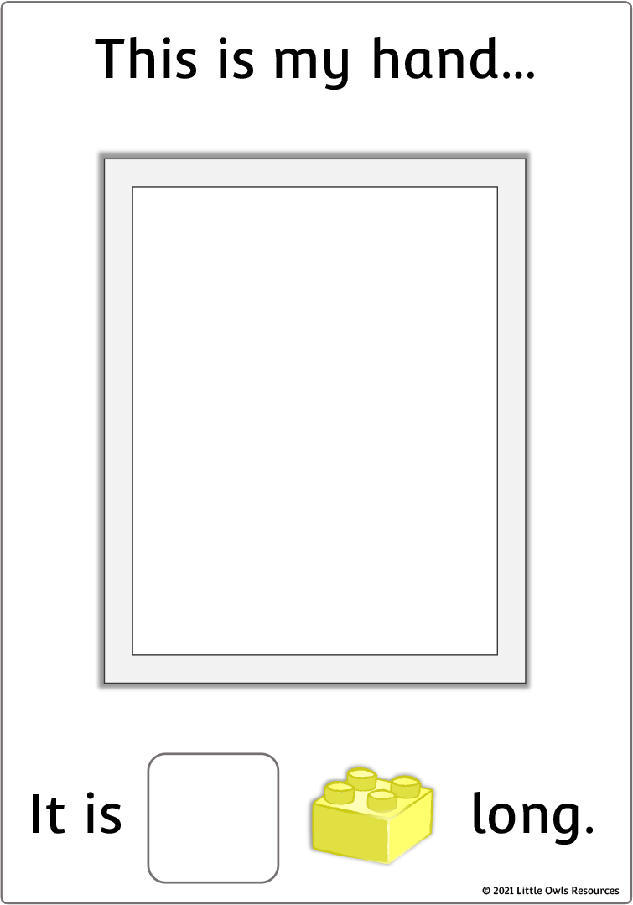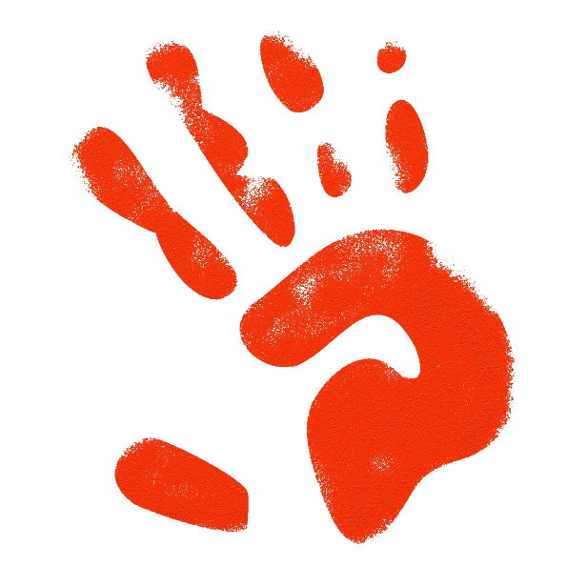

**8**

First the children are to make a handprint/footprint on the sheet. Then, they are to use a set of building bricks to see how long their hand/foot is.

*(the hand/foot can be drawn if preferred)*

© 2021 Little Owls Resources

© 2021 Little Owls Resources

This is my hand…

It is long.

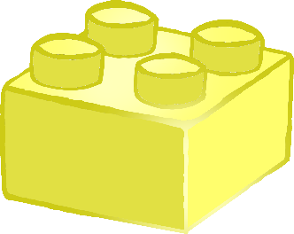

.

This is my foot…

It is long.



© 2021 Little Owls Resources