**Halloween Writing Prompts**

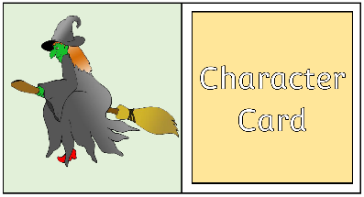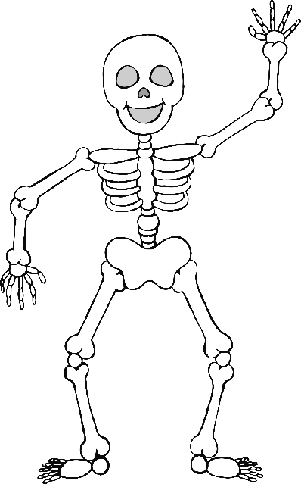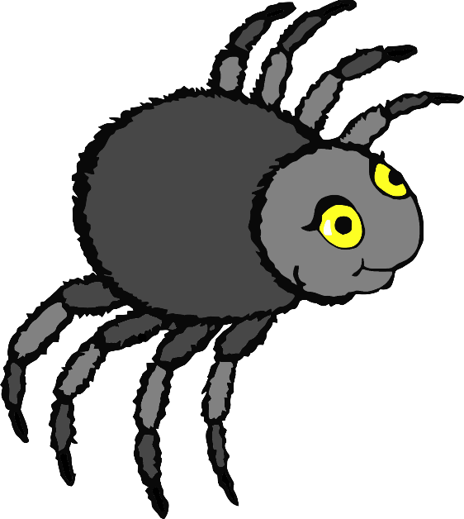

Possible Lesson/Activity

For use as part of a group activity for young children whose ideas require scribing, or for an older child to scaffold their own writing.

**N.B.** Cut around the whole card and then fold along the middle before laminating.

* Start with an opening line, e.g. Once upon a time there was a…
* Pick up a random **Character card**.
* Discuss the chosen character. What is their name? What do they like/dislike? Where do they live? Are they happy/sad?
* Scribe these ideas as a sentence or two.
* Next write…‘One day they decided to go to….
* Pick up a random **Setting card**.
* As before, discuss the chosen card, talking about what the place is, what it would sound like, smell like, etc.
* Add these thoughts to the writing.
* Next write… ‘Suddenly they noticed a…’
* Pick up a random **Object card**.
* Discuss the object, would the character like it? What would they do with it?
* Bring the story to a close with something exciting happening that (hopefully) includes the character, setting and object. Tell the children there are no cards for this part we just need their ideas…What can happen? Will it be funny? Scary?
* Read the completed story back to the children.
* Applaud them for being the authors!

Extension: Get the children to rate the story (score out of ten or thumbs up/down).

Extension: With the scribed story complete, the children could have fun acting it out or illustrating it.

© 2019 Little Owls Resources

© 2019 Little Owls Resources

© 2019 Little Owls Resources

Character

Card

Character

Card

Character

Card

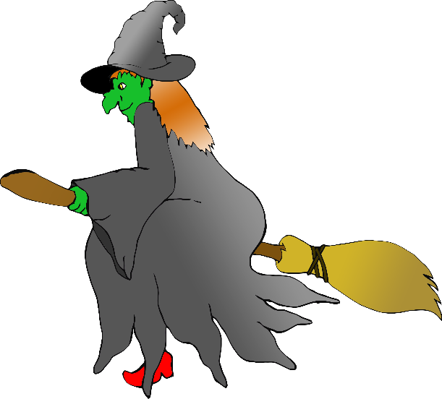

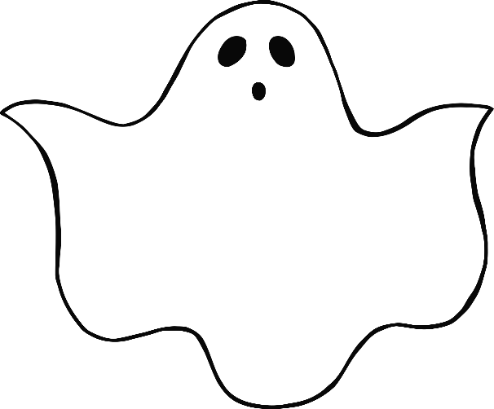

Character

Card

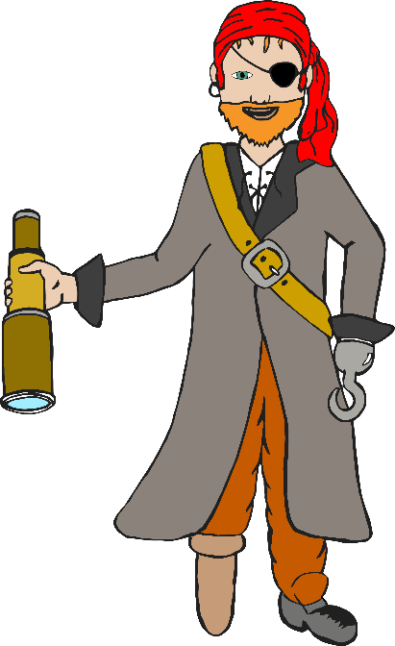

Character

Card

Character

Card

© 2019 Little Owls Resources

© 2019 Little Owls Resources

© 2019 Little Owls Resources

?

Your own idea

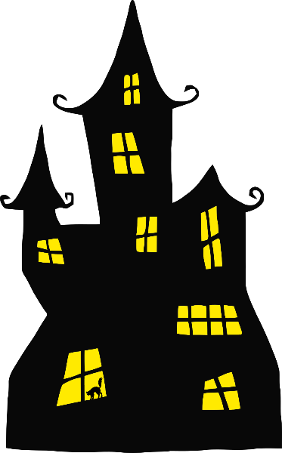

Setting

Card

Setting

Card

Setting

Card

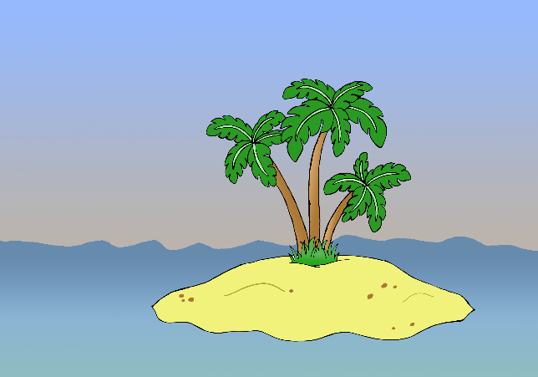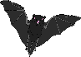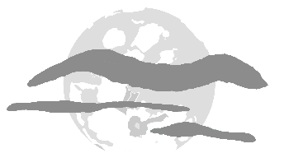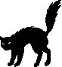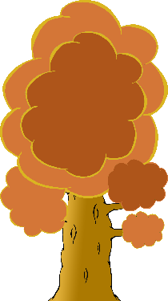

© 2019 Little Owls Resources

© 2019 Little Owls Resources

© 2019 Little Owls Resources

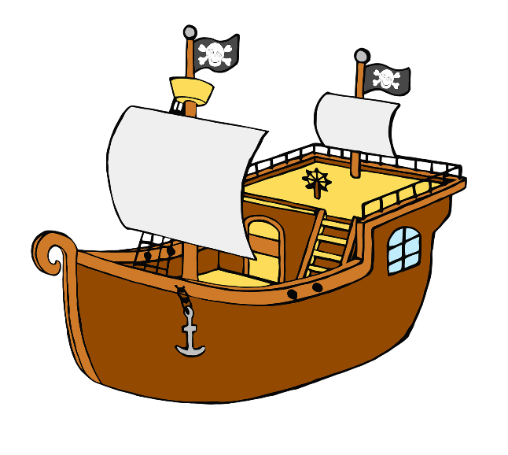

Setting

Card

Setting

Card

Setting

Card

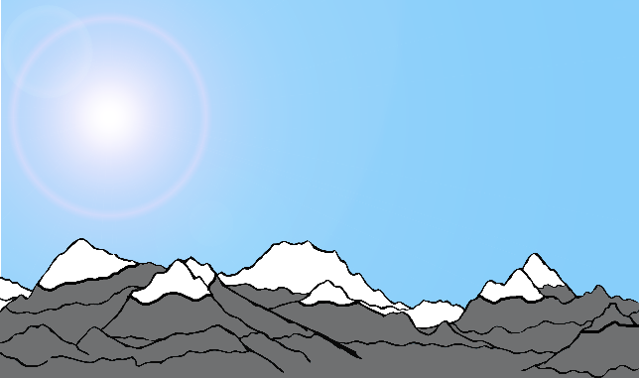

© 2019 Little Owls Resources

© 2019 Little Owls Resources

© 2019 Little Owls Resources

?

Your own idea

Object

Card

Object

Card

Object

Card

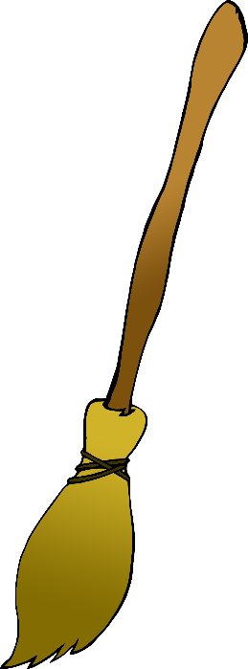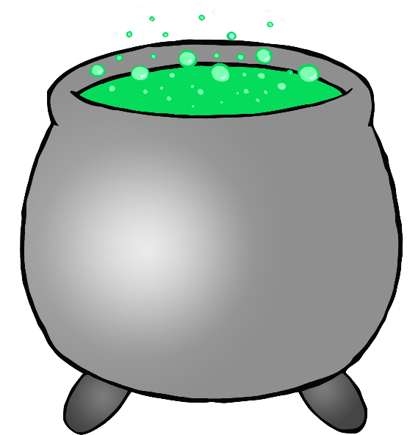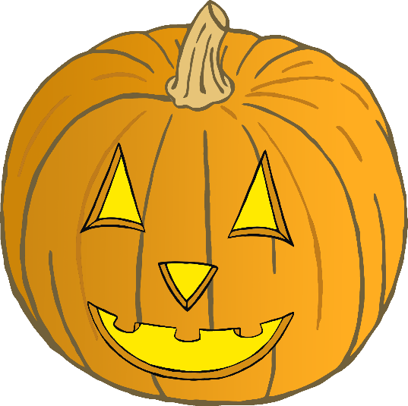

© 2019 Little Owls Resources

© 2019 Little Owls Resources

© 2019 Little Owls Resources

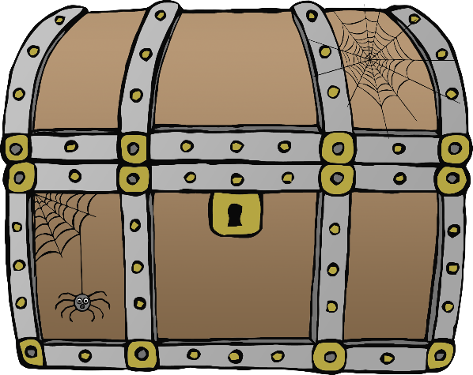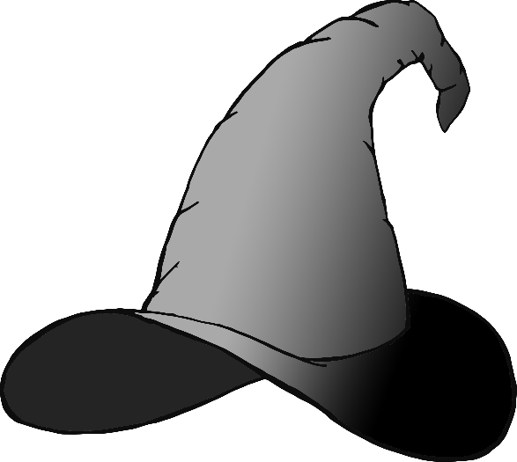

© 2019 Little Owls Resources

© 2019 Little Owls Resources

© 2019 Little Owls Resources

?

Your own idea

Object

Card

Object

Card

Object

Card