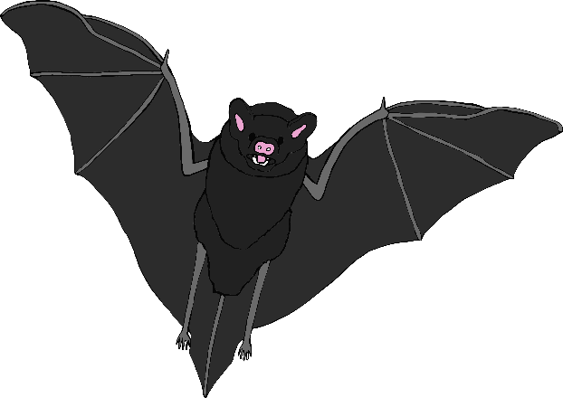

bat

broom

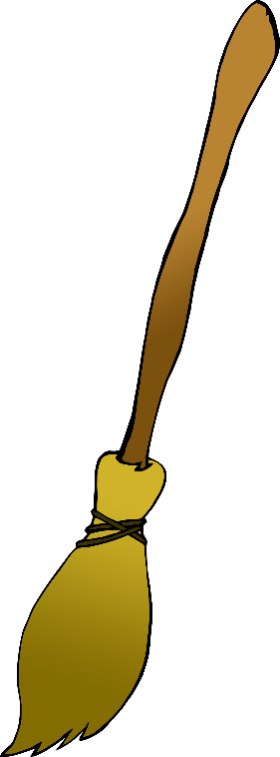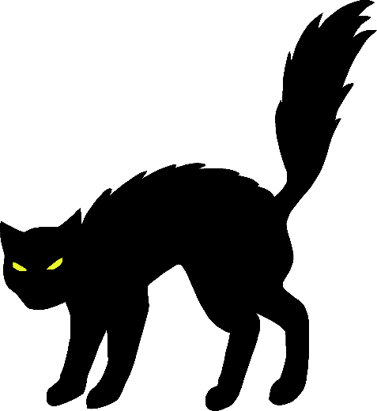

© 2019 Little Owls Resources

© 2019 Little Owls Resources

© 2019 Little Owls Resources

cat

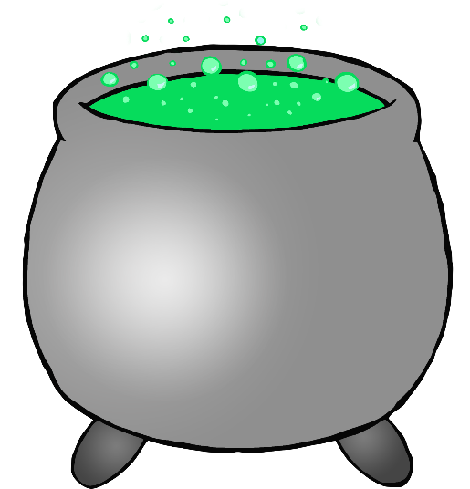

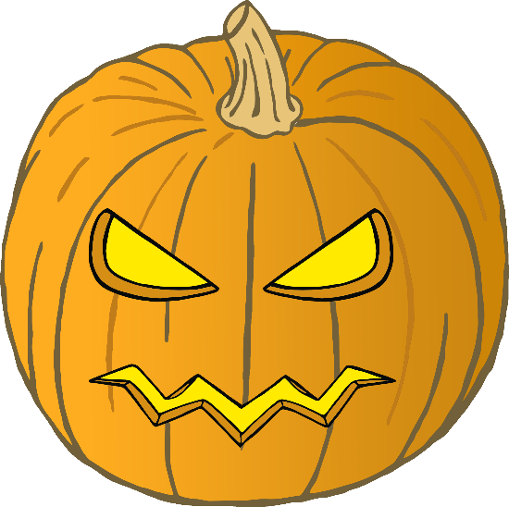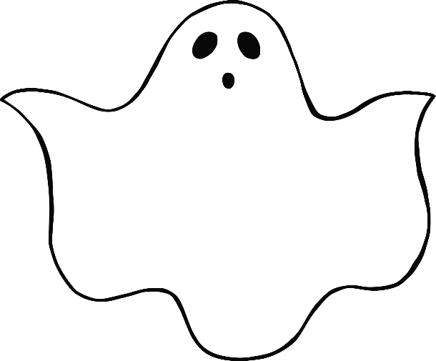

© 2019 Little Owls Resources

© 2019 Little Owls Resources

© 2019 Little Owls Resources

pumpkin

ghost

cauldron

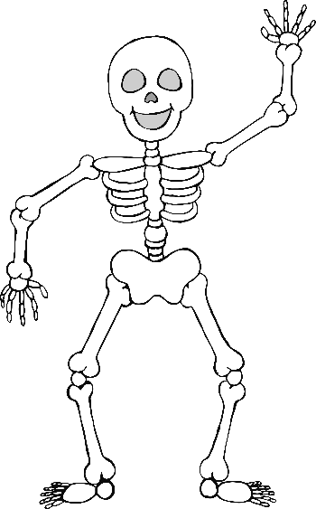

spider

skeleton

witch

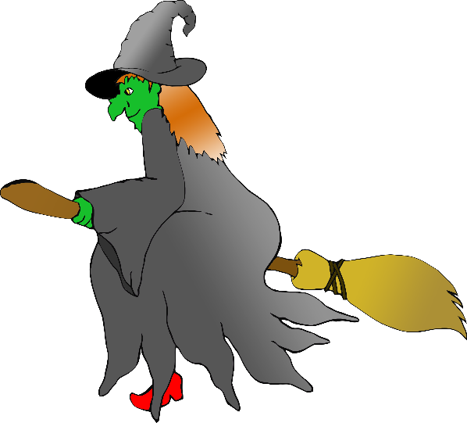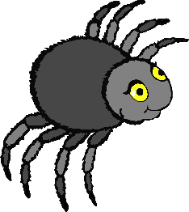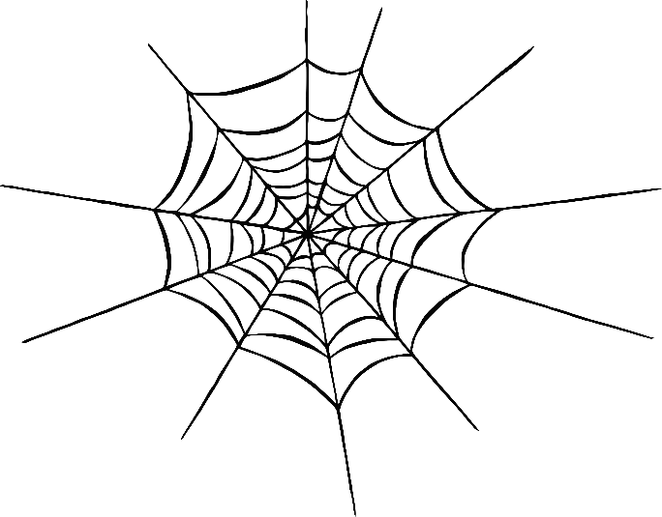

© 2019 Little Owls Resources

© 2019 Little Owls Resources

© 2019 Little Owls Resources

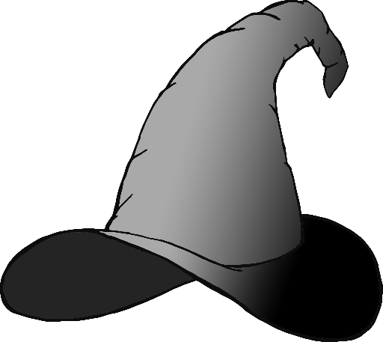

© 2019 Little Owls Resources

witch’s hat



Bat

Broom



© 2019 Little Owls Resources

© 2019 Little Owls Resources

© 2019 Little Owls Resources

Cat





© 2019 Little Owls Resources

© 2019 Little Owls Resources

© 2019 Little Owls Resources

Pumpkin

Ghost

Cauldron



Spider

Skeleton

Witch



© 2019 Little Owls Resources

© 2019 Little Owls Resources

© 2019 Little Owls Resources



© 2019 Little Owls Resources

Witch’s Hat