These cards can be laminated for repeated use. Each of the designs has a dotted line card and a card with a blank space.

**Halloween mark making cards**

© 2021 Little Owls Resources

© 2021 Little Owls Resources

© 2021 Little Owls Resources

© 2021 Little Owls Resources

© 2021 Little Owls Resources

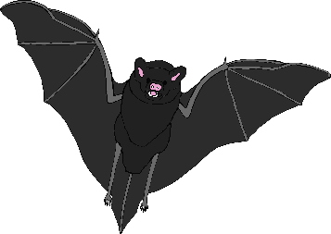



© 2021 Little Owls Resources

© 2021 Little Owls Resources

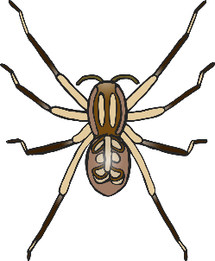

© 2021 Little Owls Resources

© 2021 Little Owls Resources

© 2021 Little Owls Resources

© 2021 Little Owls Resources

© 2021 Little Owls Resources

© 2021 Little Owls Resources