© 2022 Little Owls Resources

Finish the picture!

Finish the picture!

© 2022 Little Owls Resources

Finish the picture!

© 2022 Little Owls Resources

© 2022 Little Owls Resources

Finish the picture!

© 2022 Little Owls Resources

Finish the picture!

© 2022 Little Owls Resources

Finish the picture!

© 2022 Little Owls Resources

Finish the picture!

© 2022 Little Owls Resources

Finish the picture!

Finish the picture!

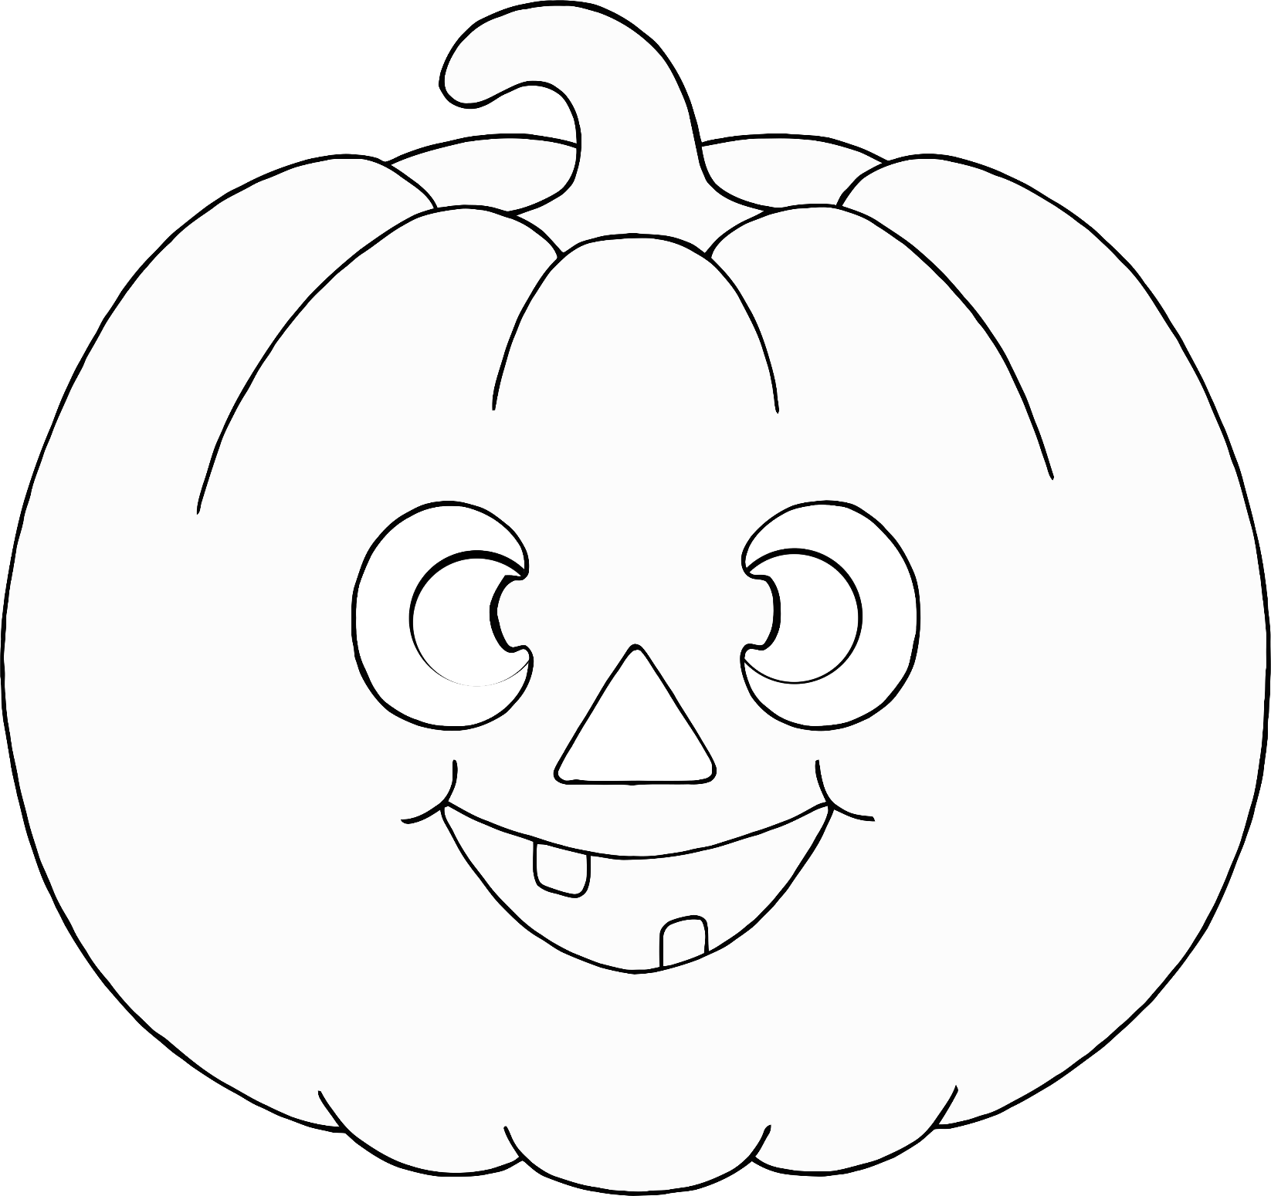

© 2022 Little Owls Resources

© 2022 Little Owls Resources

Finish the picture!



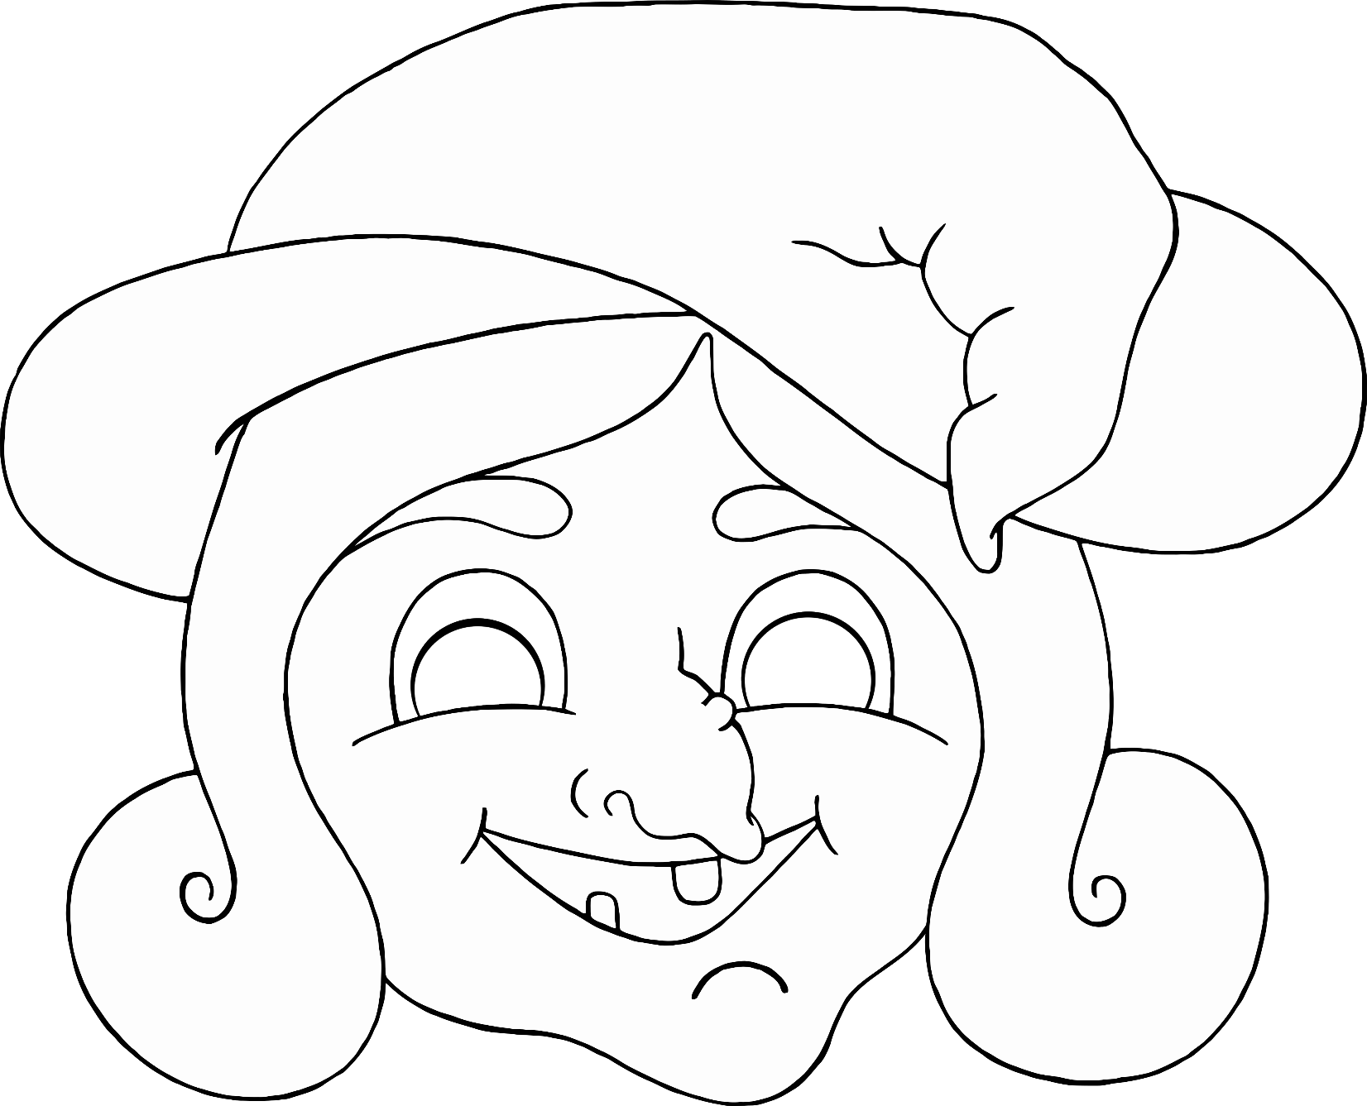

Finish the picture!

© 2022 Little Owls Resources



© 2022 Little Owls Resources

Finish the picture!