Draw a face for this ghost.

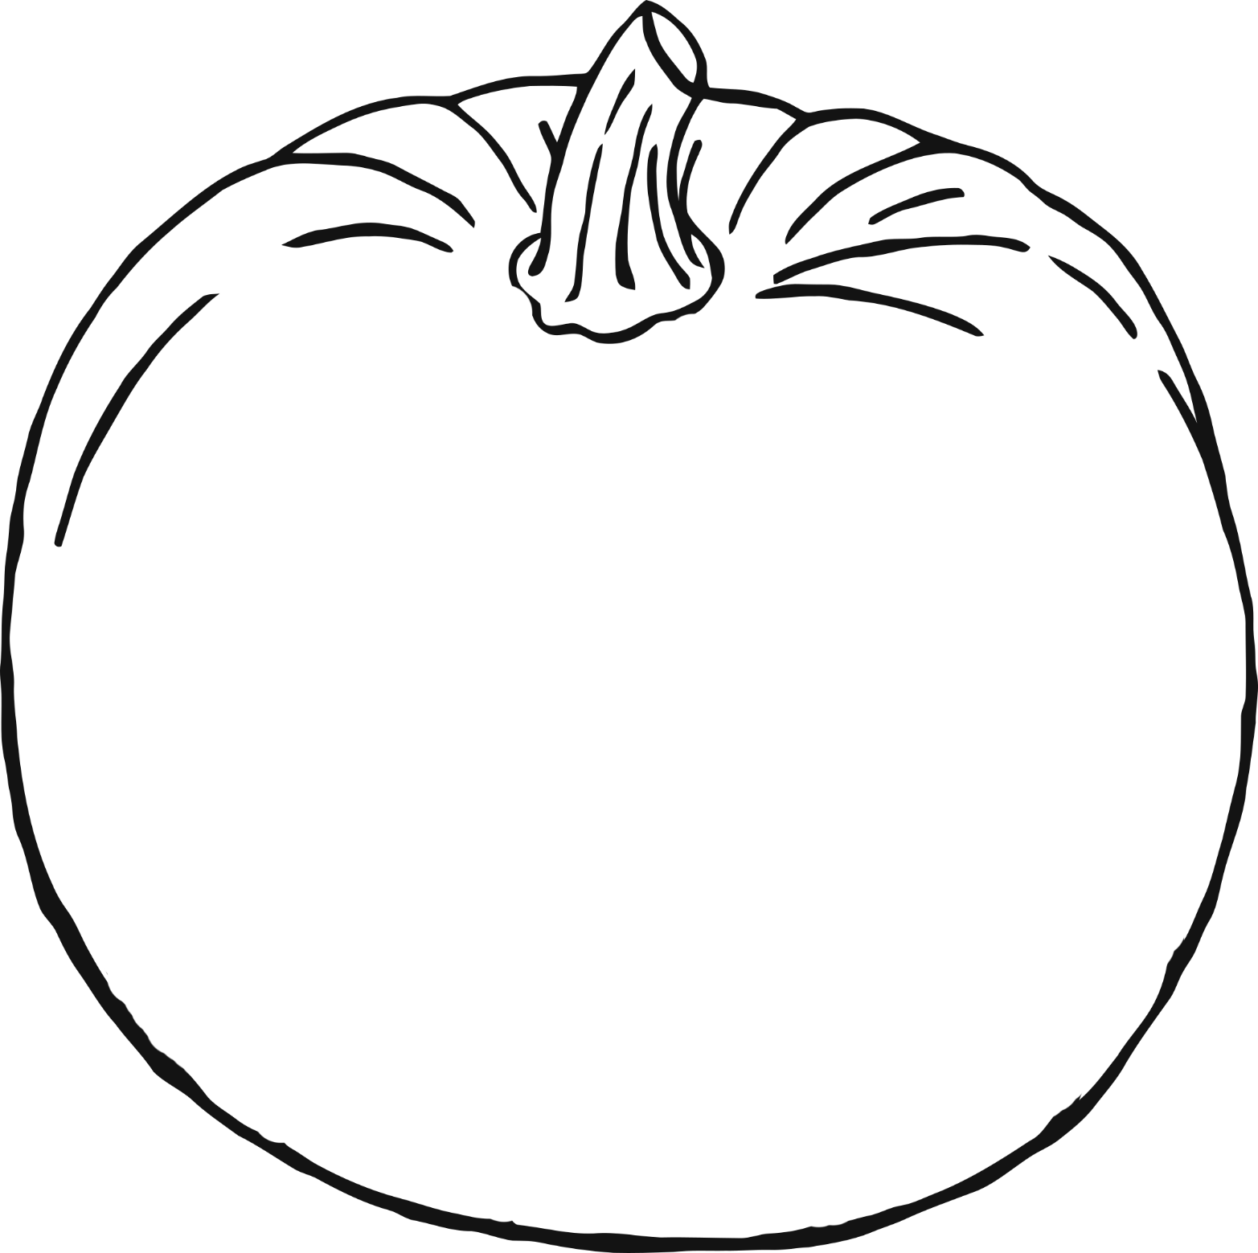

Draw a face for this pumpkin.

Draw three ingredients for the cauldron.

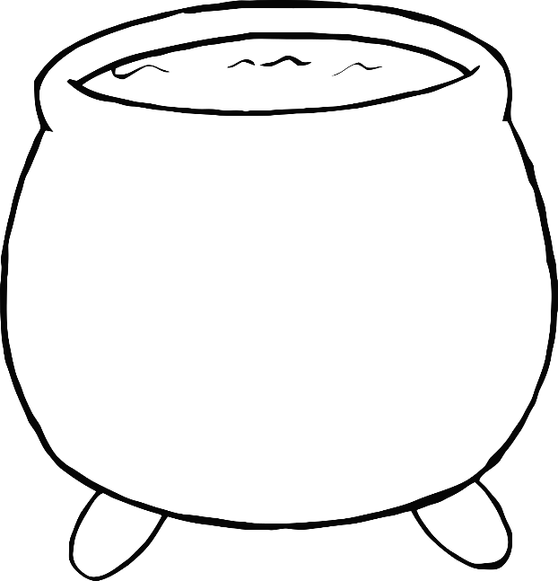

3

2

1

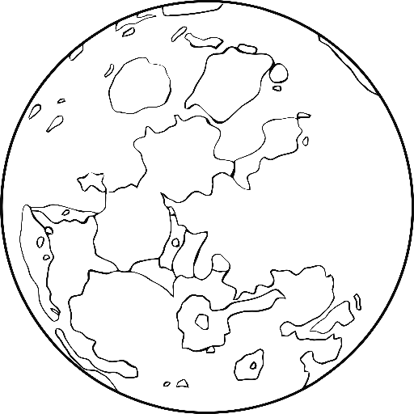

Draw some characters in this spooky scene.

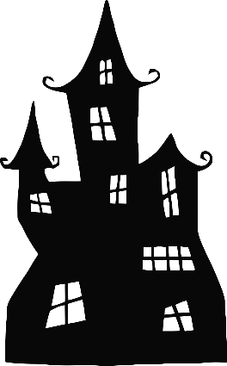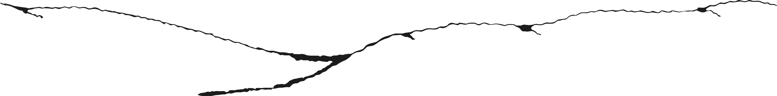

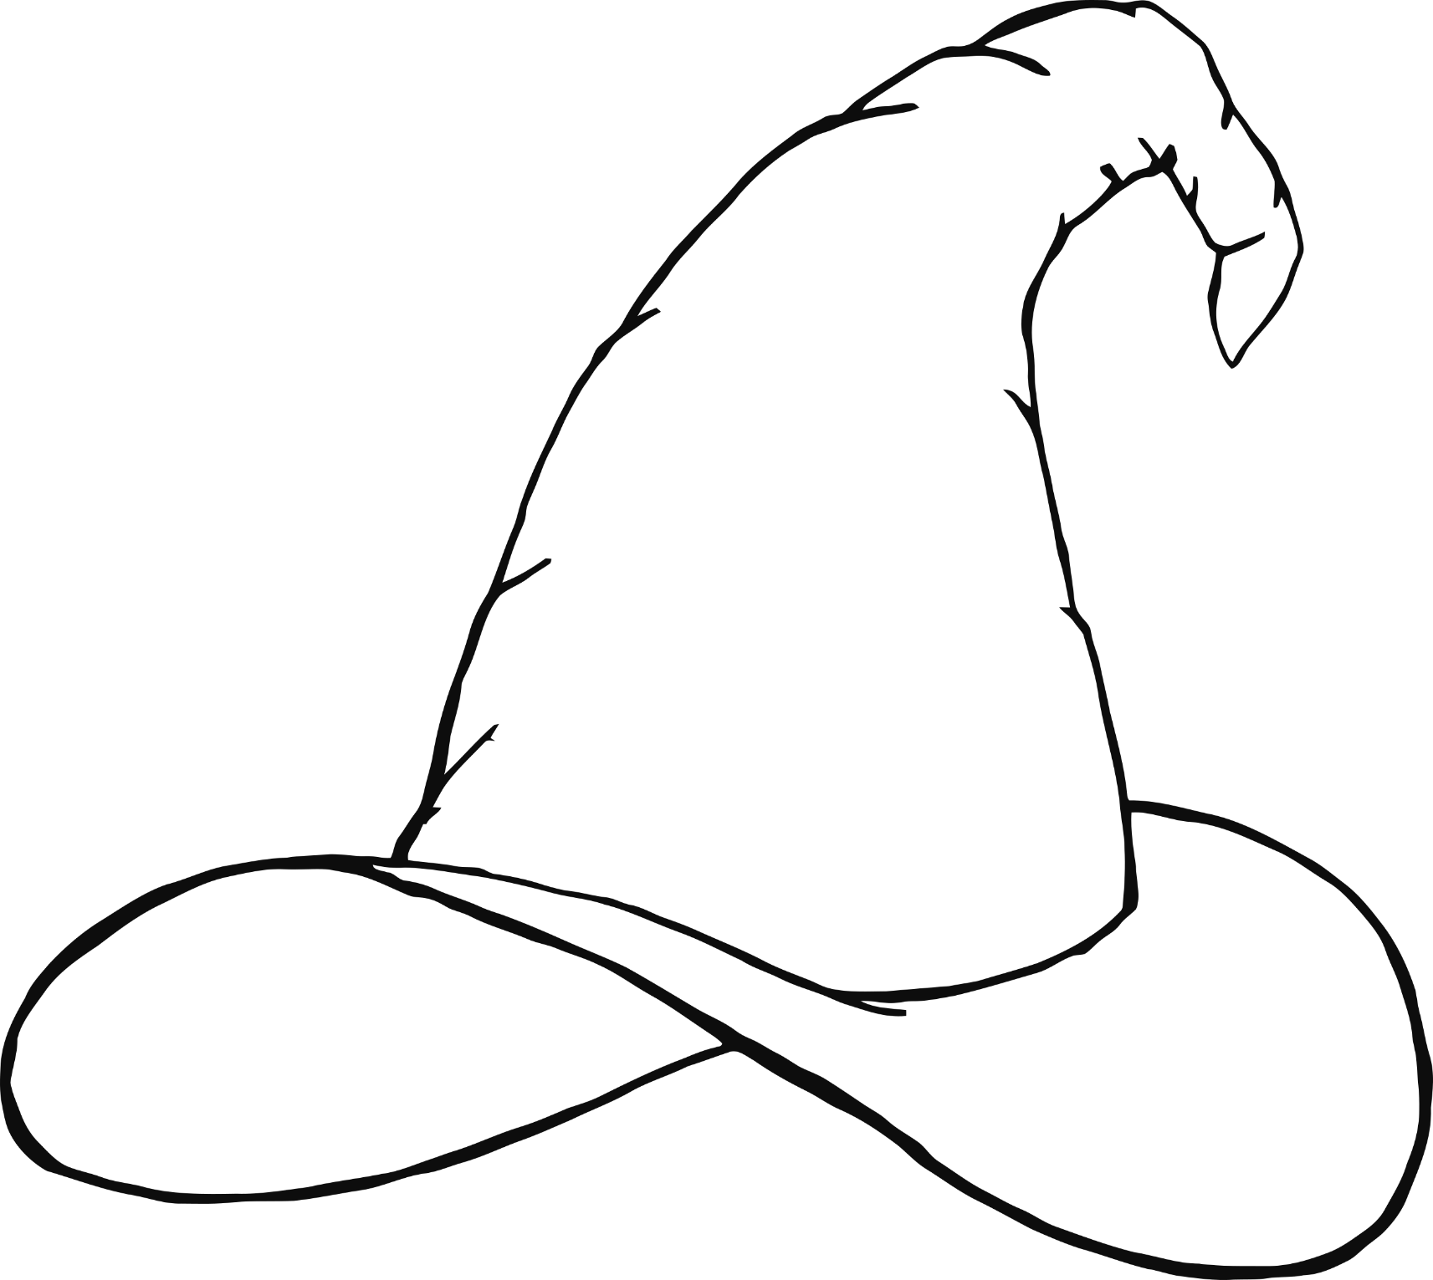

Design a special witch’s hat!

Draw what you can see through the spooky window.