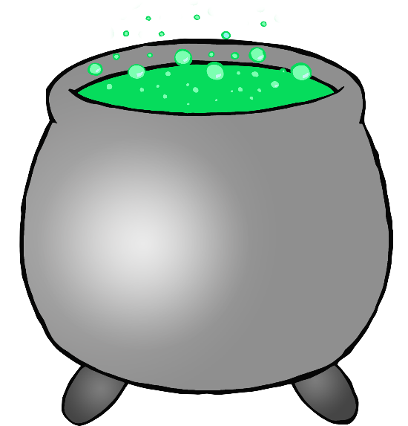

© 2019 Little Owls Resources

© 2019 Little Owls Resources

A big pot filled with a potion that bubbles and pops!

Cauldron

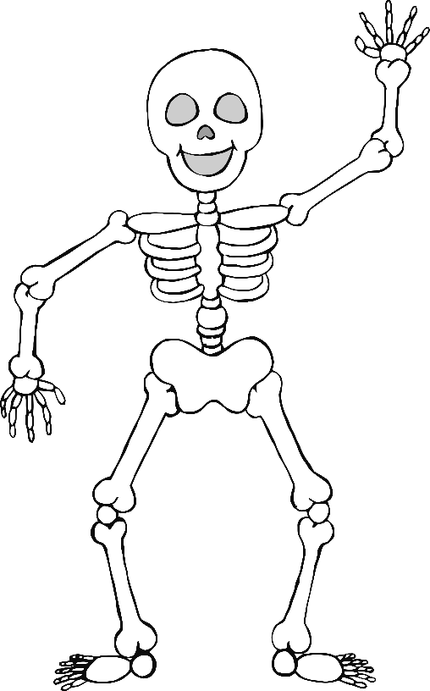

© 2019 Little Owls Resources

© 2019 Little Owls Resources

I have no muscles!

I’m made of bones!

Skeleton

I wear a pointy hat and fly on my broomstick!

Witch

© 2019 Little Owls Resources

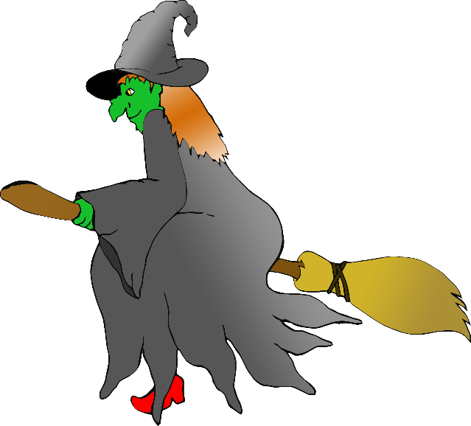

© 2019 Little Owls Resources

I grew from a seed and now I have a funny face!

Pumpkin

© 2019 Little Owls Resources

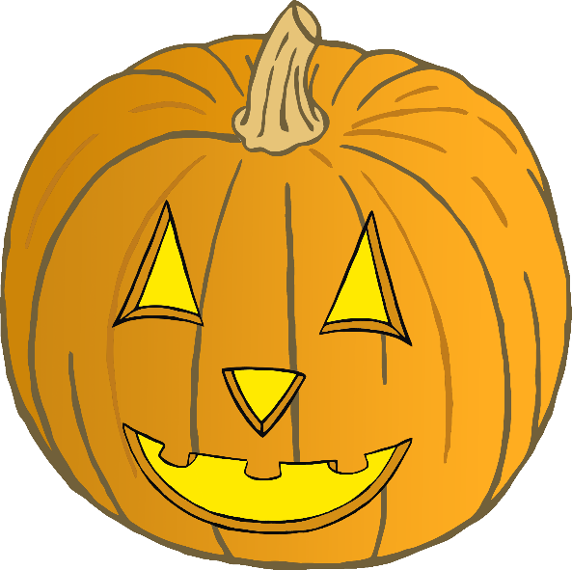

© 2019 Little Owls Resources

I catch my food in a web!

Spider

© 2019 Little Owls Resources

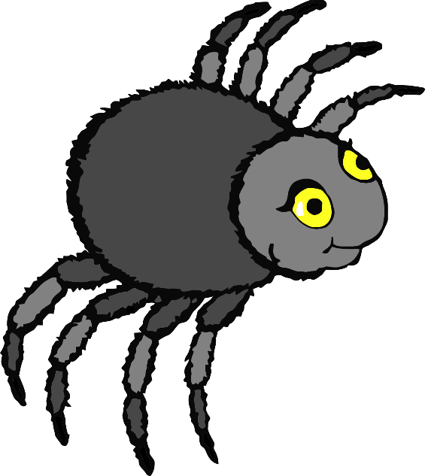

© 2019 Little Owls Resources

I have four legs and I arch my back if I am angry!

Cat

© 2019 Little Owls Resources

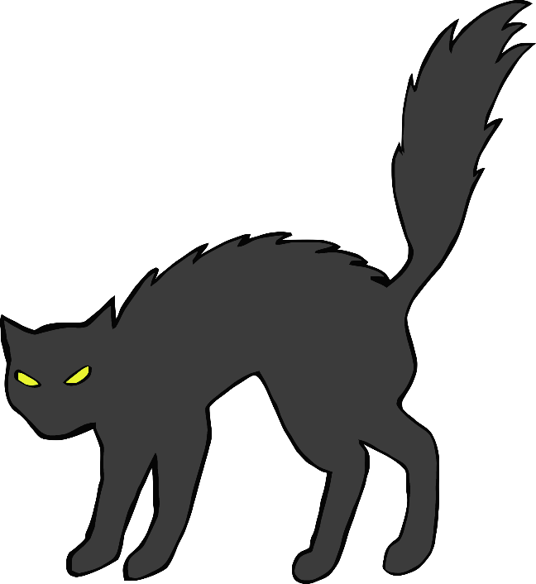

© 2019 Little Owls Resources

I float around and make spooky noises!

Ghost

© 2019 Little Owls Resources

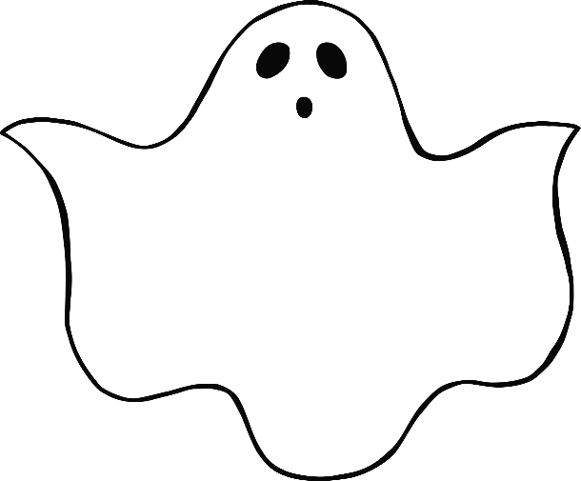

© 2019 Little Owls Resources

Most people clean with me, but a witch can fly on me!

Broomstick

© 2019 Little Owls Resources

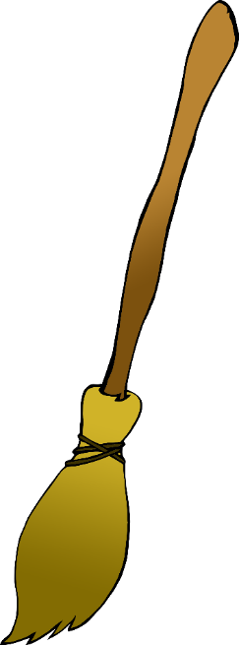

© 2019 Little Owls Resources

I run quietly along the floor so no-one sees me!

Mouse

© 2019 Little Owls Resources

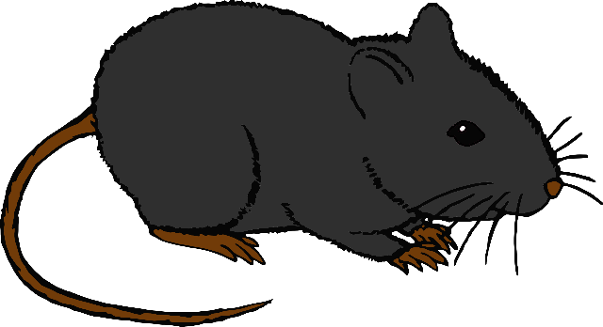

© 2019 Little Owls Resources

I can’t see very well, but I love to fly at night!

Bat

© 2019 Little Owls Resources

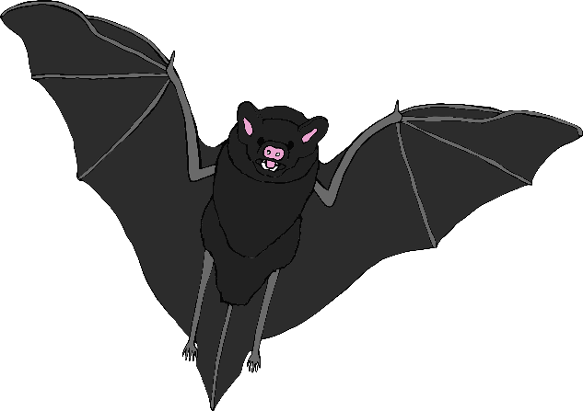

© 2019 Little Owls Resources