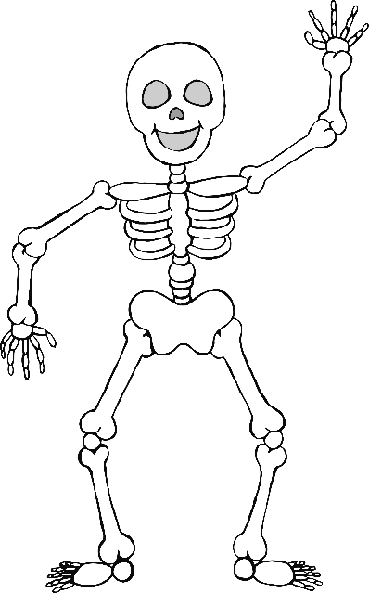

© 2020 Little Owls Resources

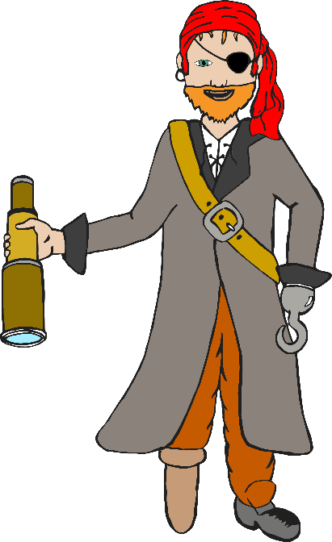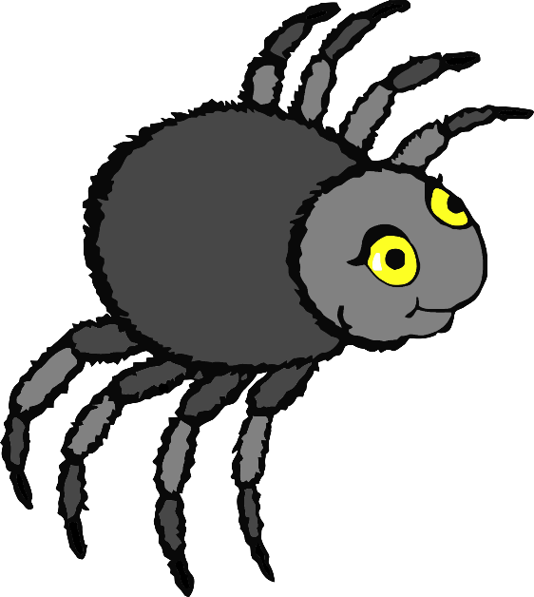

© 2020 Little Owls Resources

© 2020 Little Owls Resources

© 2020 Little Owls Resources

© 2020 Little Owls Resources

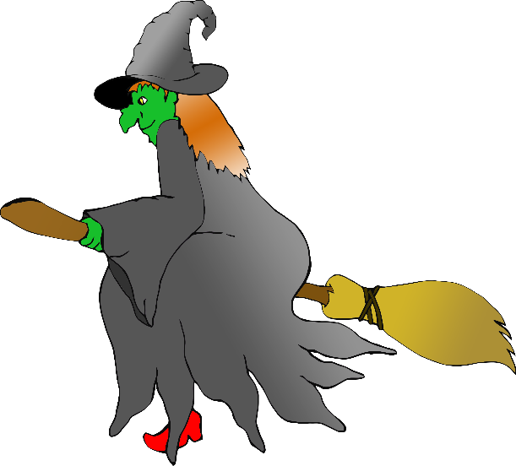

© 2020 Little Owls Resources

© 2020 Little Owls Resources

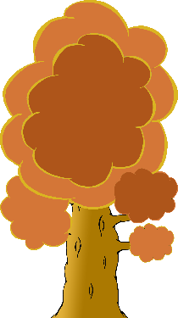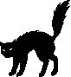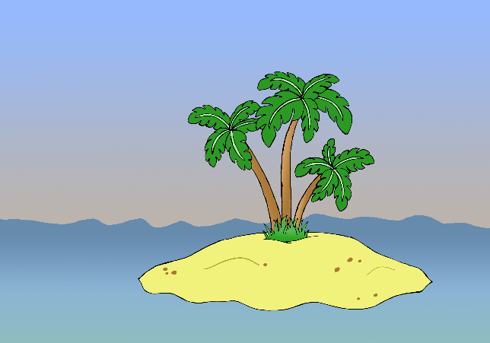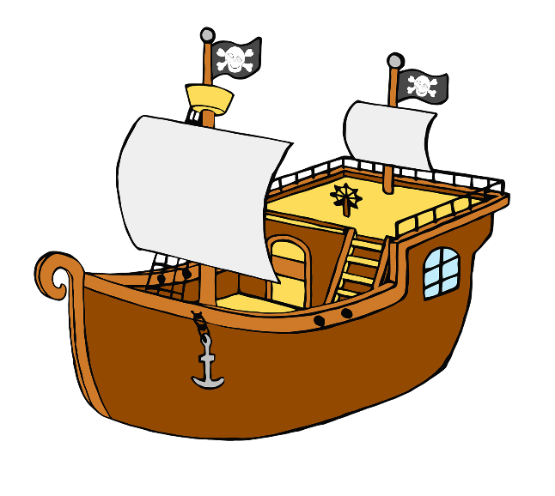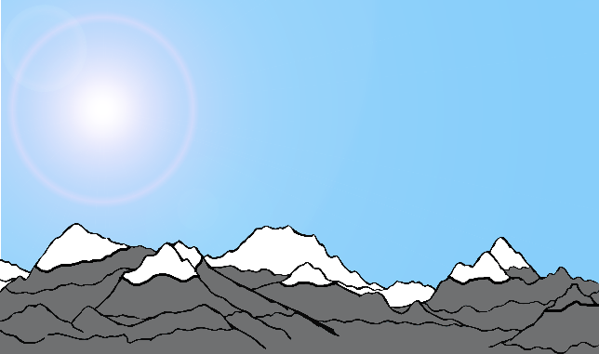

© 2020 Little Owls Resources

© 2020 Little Owls Resources

© 2020 Little Owls Resources

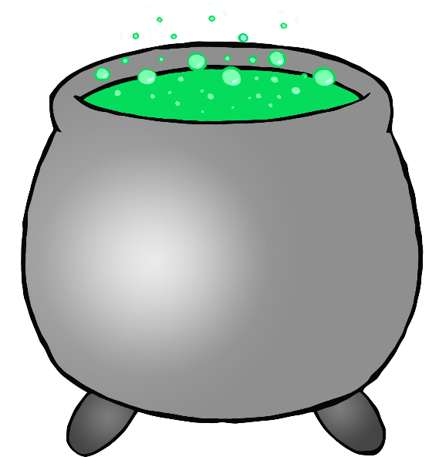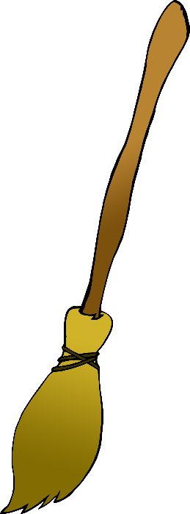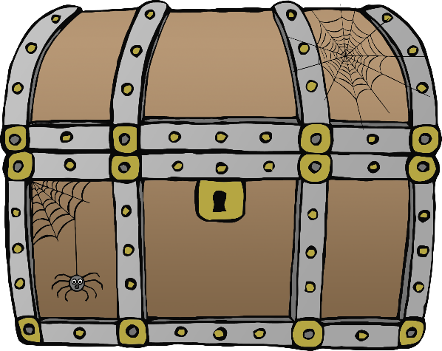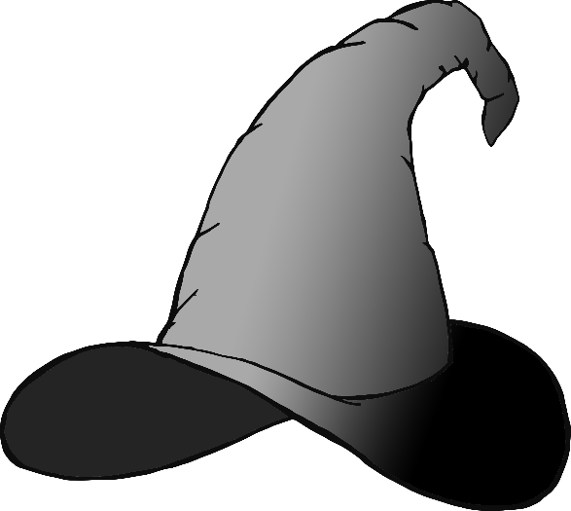

© 2020 Little Owls Resources

© 2020 Little Owls Resources

© 2020 Little Owls Resources

© 2020 Little Owls Resources

© 2020 Little Owls Resources

Character

Setting

Object

____________________________________________________________________________________________________________________________________________________________________________

© 2020 Little Owls Resources

________________________________________________________________________________________________

Character

Setting

Object

© 2020 Little Owls Resources

© 2020 Little Owls Resources

Character

Setting

Object