© 2019 Little Owls Resources

© 2019 Little Owls Resources

© 2019 Little Owls Resources

© 2019 Little Owls Resources

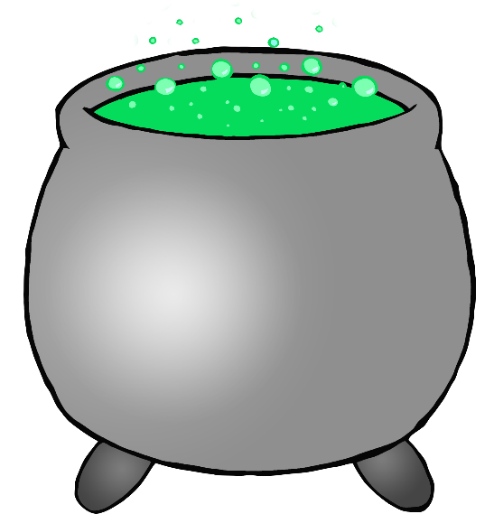

1

2

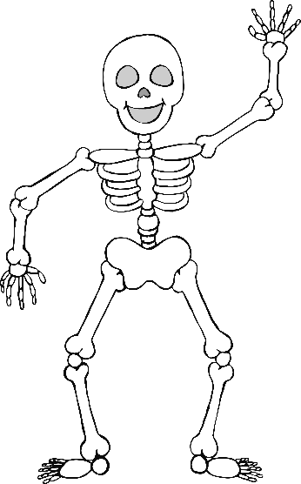

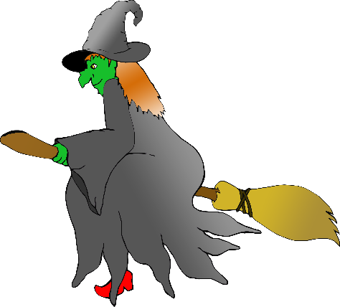

© 2019 Little Owls Resources

© 2019 Little Owls Resources

© 2019 Little Owls Resources

© 2019 Little Owls Resources

3



4

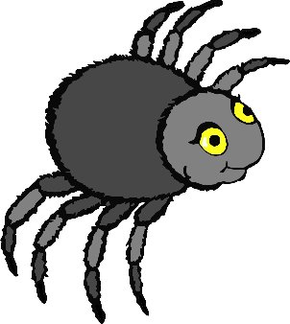

© 2019 Little Owls Resources

© 2019 Little Owls Resources

© 2019 Little Owls Resources

© 2019 Little Owls Resources

5

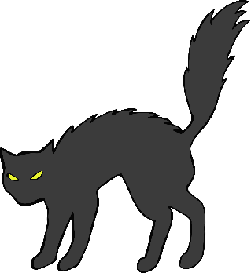

6



© 2019 Little Owls Resources

© 2019 Little Owls Resources

© 2019 Little Owls Resources

© 2019 Little Owls Resources

7

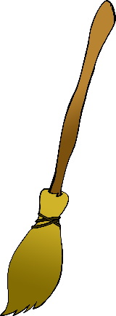

8

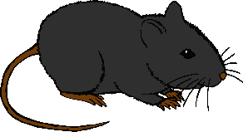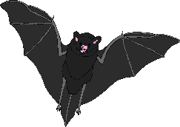

© 2019 Little Owls Resources

© 2019 Little Owls Resources

© 2019 Little Owls Resources

© 2019 Little Owls Resources

9

10



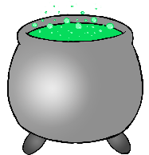

© 2019 Little Owls Resources

© 2019 Little Owls Resources

© 2019 Little Owls Resources

© 2019 Little Owls Resources



11

12

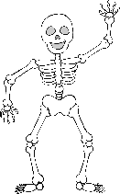



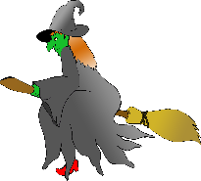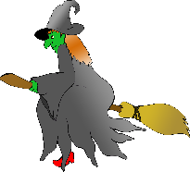

© 2019 Little Owls Resources

© 2019 Little Owls Resources

© 2019 Little Owls Resources

© 2019 Little Owls Resources

13

14



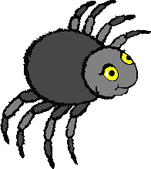

© 2019 Little Owls Resources

© 2019 Little Owls Resources

© 2019 Little Owls Resources

© 2019 Little Owls Resources

15

16

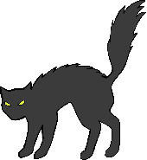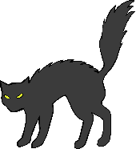



© 2019 Little Owls Resources

© 2019 Little Owls Resources

© 2019 Little Owls Resources

© 2019 Little Owls Resources

17

18

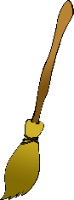

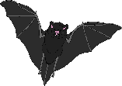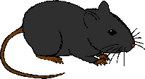

© 2019 Little Owls Resources

© 2019 Little Owls Resources

© 2019 Little Owls Resources

© 2019 Little Owls Resources

19

20