Halloween Character Sheets

Sheets to help children to build up a Halloween character in preparation for writing/scribing.

Variety of sheet types for different activities….

p1-5: Coloured pictures.

p6-10: BW pictures for Colouring in.

p11-15: Coloured pictures with blank text boxes.

p16-20: BW pictures for Colouring in with blank text boxes.

p21: Blank picture box with blank text boxes.

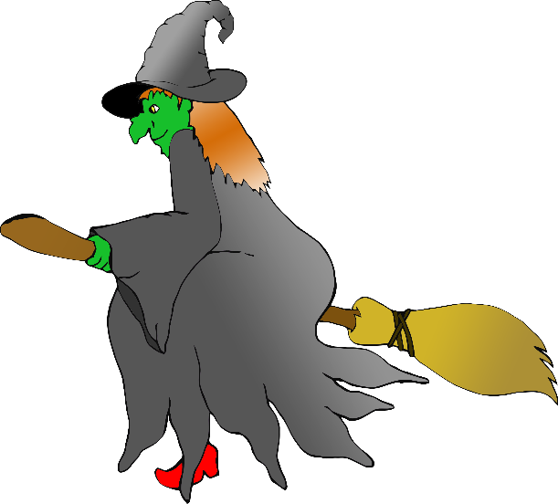

**Character Sheet**

Name:

Age:

Favourite food:

Favourite drink:

Scared of…

Special ability:

**Character Sheet**

Name:

Age:

Favourite food:

Favourite drink:

Scared of…

Special ability:

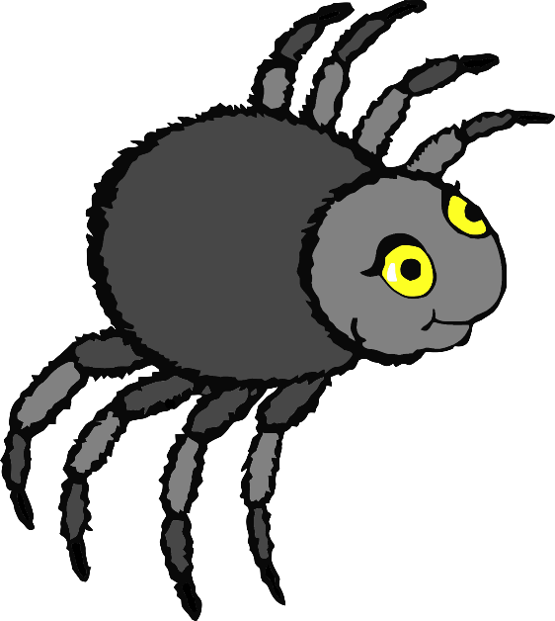

**Character Sheet**

Name:

Age:

Favourite food:

Favourite drink:

Scared of…

Special ability:

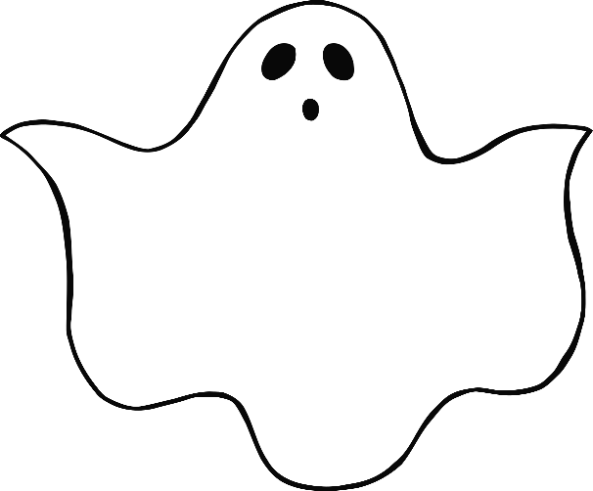

**Character Sheet**

Name:

Age:

Favourite food:

Favourite drink:

Scared of…

Special ability:

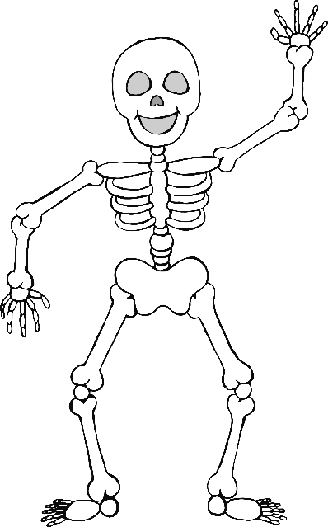

**Character Sheet**

Name:

Age:

Favourite food:

Favourite drink:

Scared of…

Special ability:

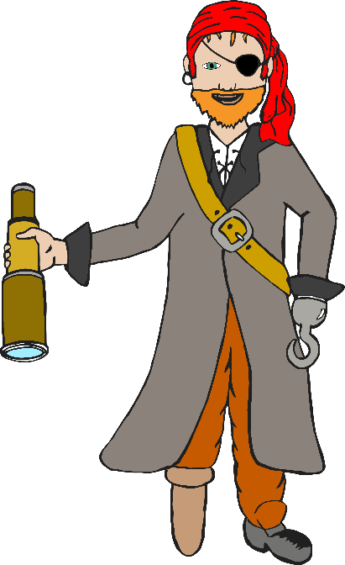

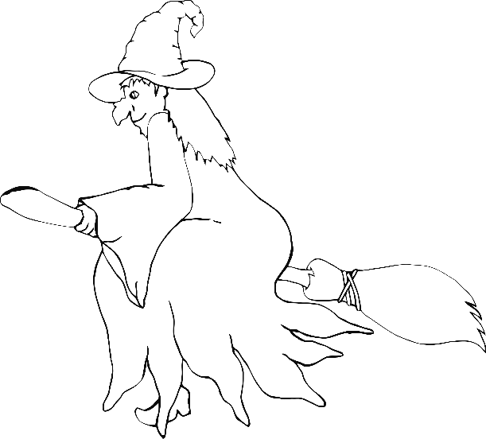

**Character Sheet**

Name:

Age:

Favourite food:

Favourite drink:

Scared of…

Special ability:

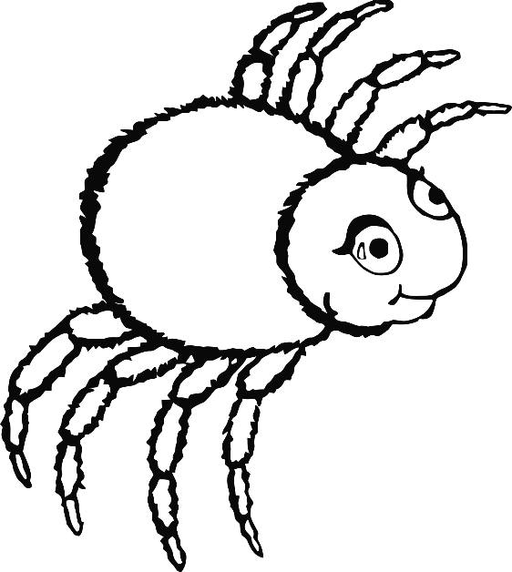

**Character Sheet**

Name:

Age:

Favourite food:

Favourite drink:

Scared of…

Special ability:

**Character Sheet**

Name:

Age:

Favourite food:

Favourite drink:

Scared of…

Special ability:



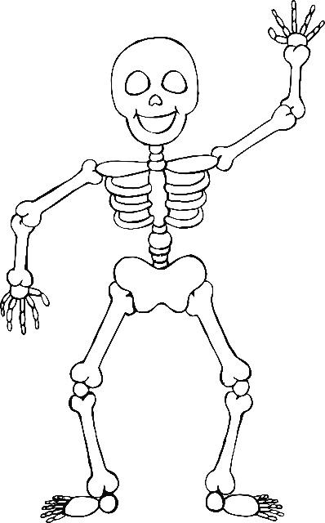

**Character Sheet**

Name:

Age:

Favourite food:

Favourite drink:

Scared of…

Special ability:

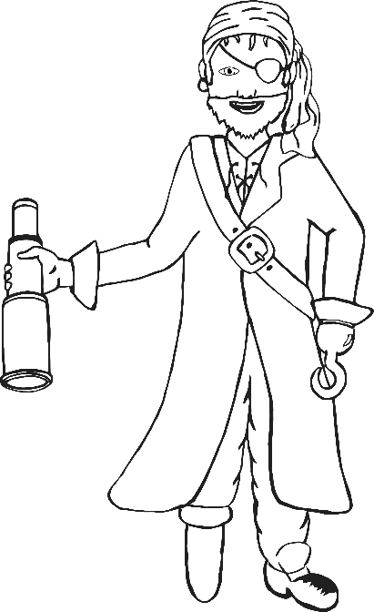

**Character Sheet**

Name:

Age:

Favourite food:

Favourite drink:

Scared of…

Special ability:

**Character Sheet**



**Character Sheet**



**Character Sheet**



**Character Sheet**



**Character Sheet**



**Character Sheet**



**Character Sheet**



**Character Sheet**



**Character Sheet**



**Character Sheet**



**Character Sheet**